**COVID TEST**

**&**

**VACCINATION SYSTEM**

**PROJECT GROUP MEMBER**

|  |  |
| --- | --- |
| **Students Id** | **Students Name** |
| ***Student1426616*** | ***Syed Muhammad Zain Sarfraz*** |
| ***Student1419863*** | ***Tooba Tariq*** |
| ***Student1425117*** | ***Aqsa Abdul Jabbar*** |

**CURRICULUM BATCH**

**6740 2210B3**

**FACULTY**

**SIR EBAD-UDDIN**

**CO-ORDINATOR**

**MISS MUNNAZAH**

**CERTIFICATE**

This is to certify that the dissertation entitled

**“COVID TEST & VACCINATION SYSTEM”**

is **SYED MUHAMMAD ZAIN SARFRAZ**

**STUDENT1426616, TOOBA TARIQ**

**Student1419863, and AQSA ABDUL**

**JABBAR Student1425117** in their partial

fulfilment of the requirement of the award

of the Aptech Computer Certified.

**ADMIN PANEL:**

**ADMIN LOGIN**

Here You can Login in Your Admin Account.

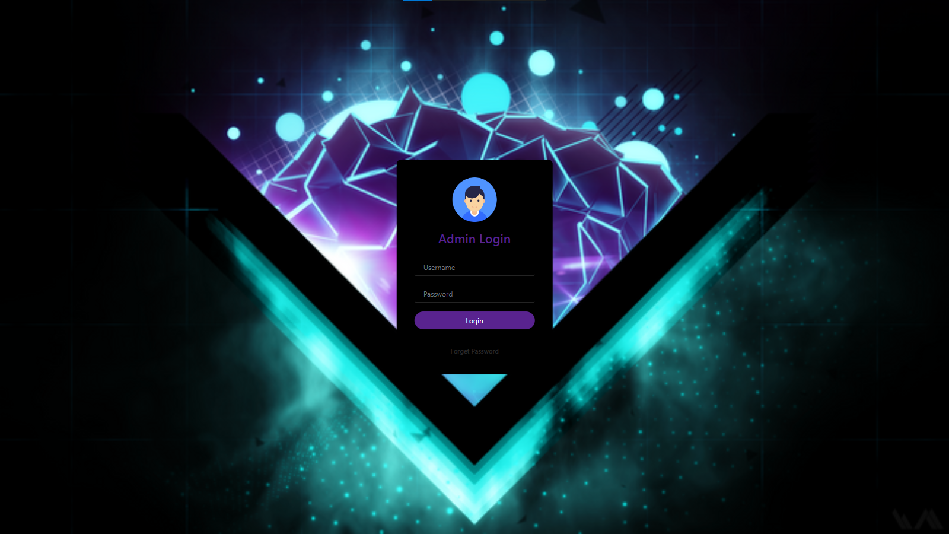

**HOME:**

Admin can read the details of login users.

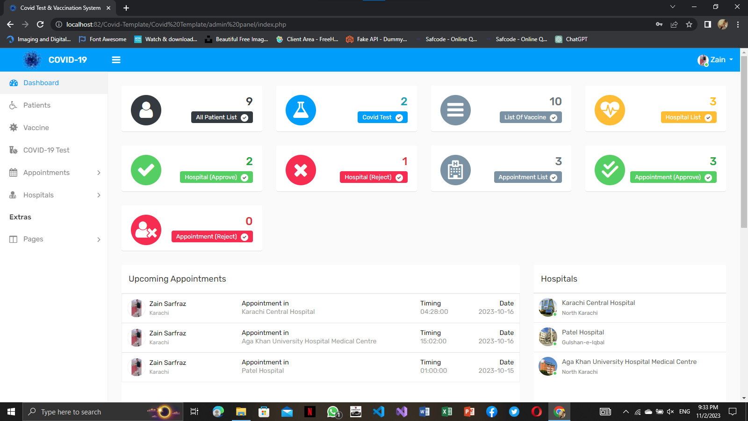

**PATIENTS:**

This is a patient list. where you can saw all patient

details..

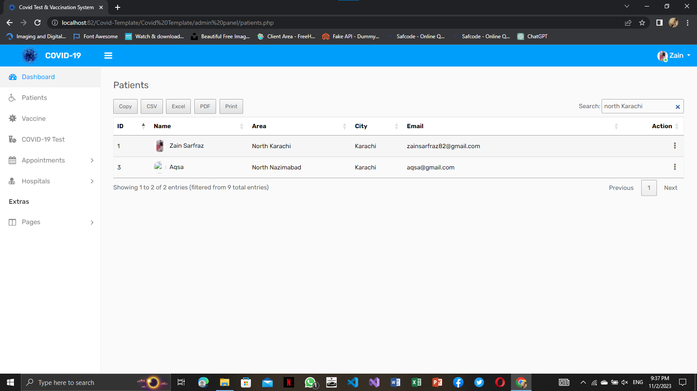

**VACCINE:**

Vaccine list are available here.

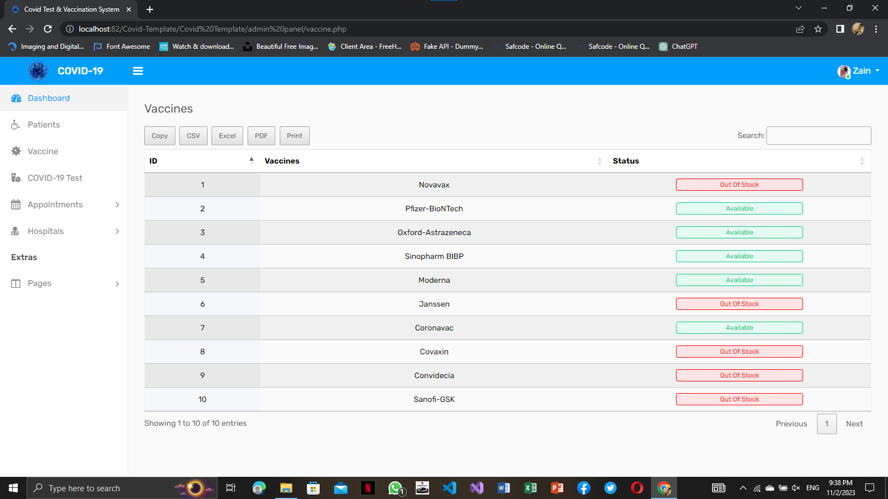

**COVID-19 TEST:**

Here is a Covid-19 Test List.

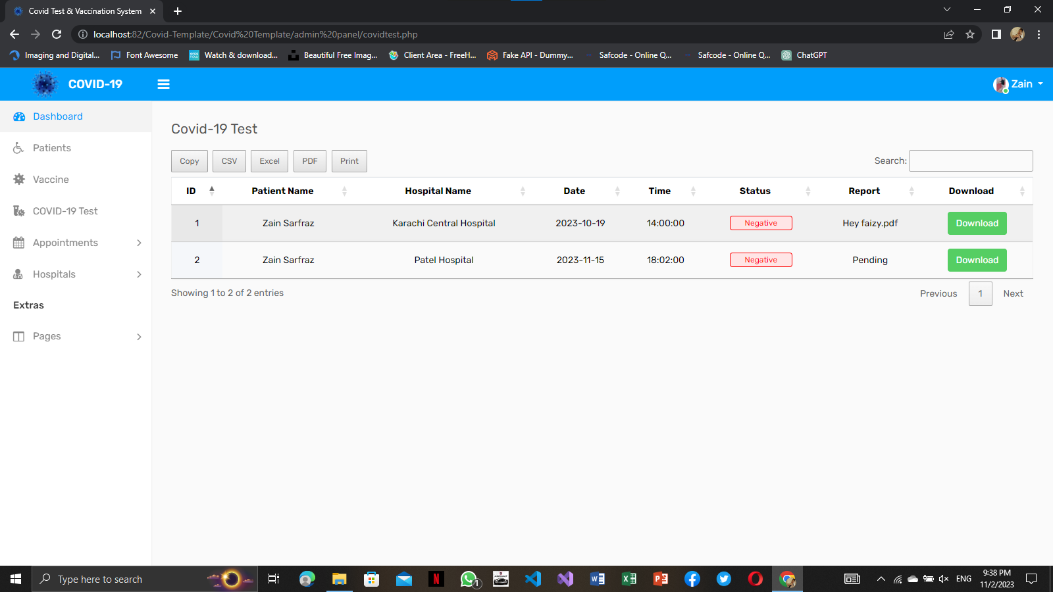

**APPOINTMENT:**

Appointment list you can easily saw there.

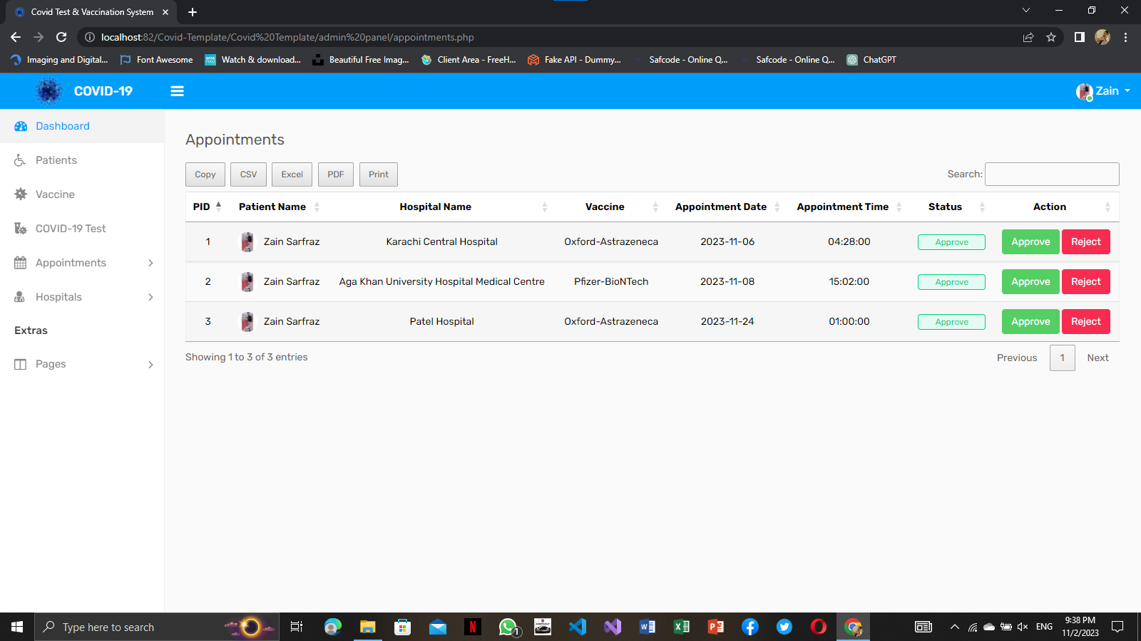

**APPROVE APPOIINTMENT:**

Admin can see the approve user appointment.

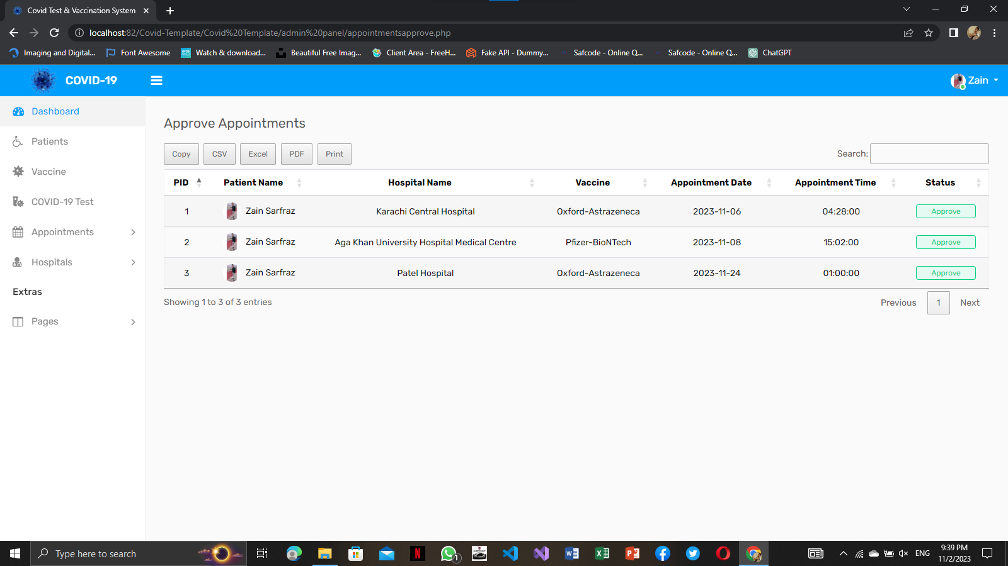

**REJECT APPOIINTMENT:**

Admin can see the Reject user appointment..

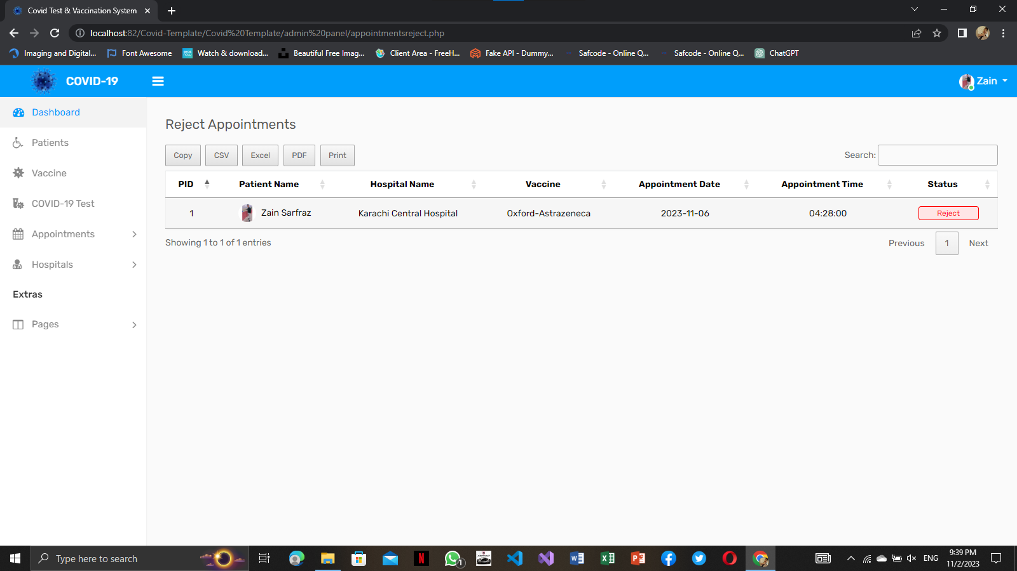

**HOSPITALS:**

Hospital list you can easily saw there.

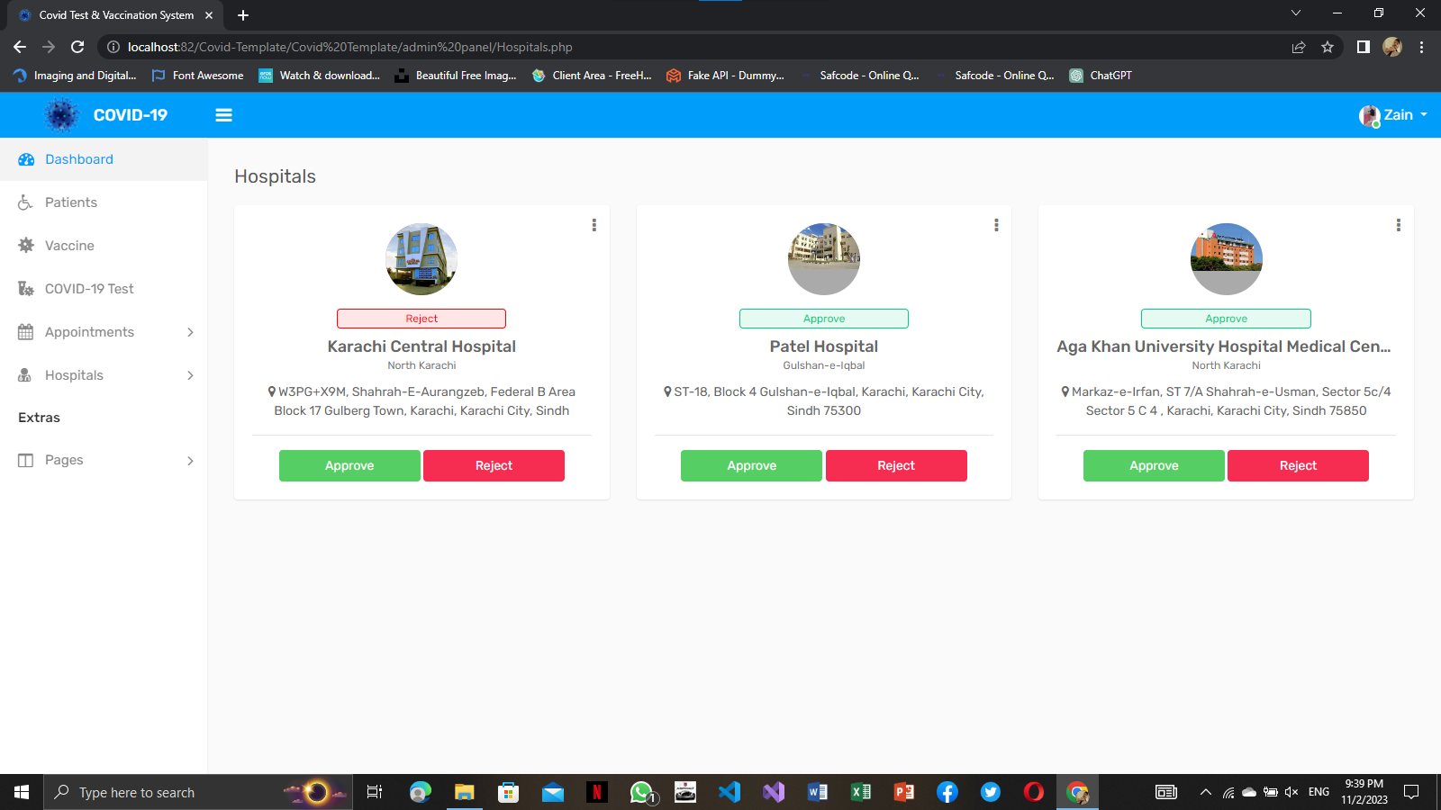

**APPROVE HOSPITAL:**

Admin can do approve Hospital

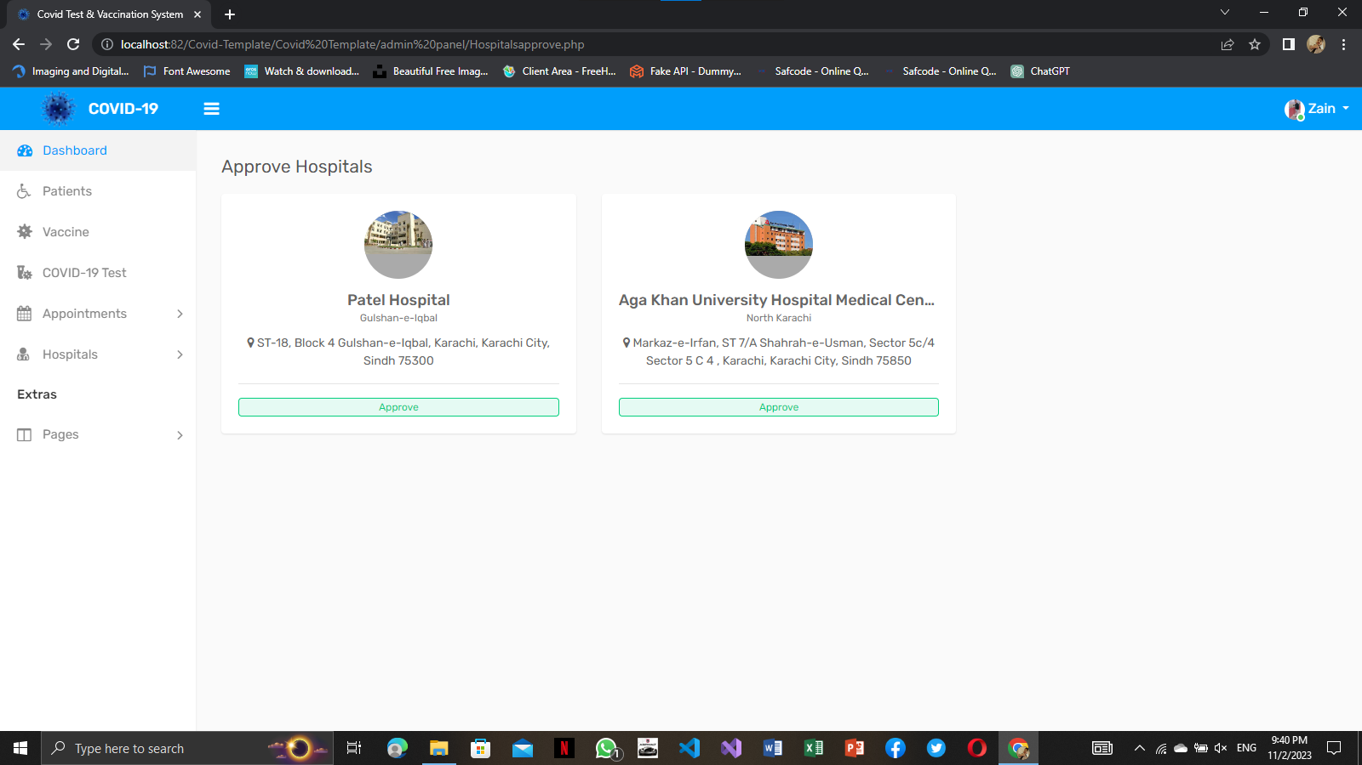

**REJECT HOSPITAL:**

Admin can do Reject Hospital.

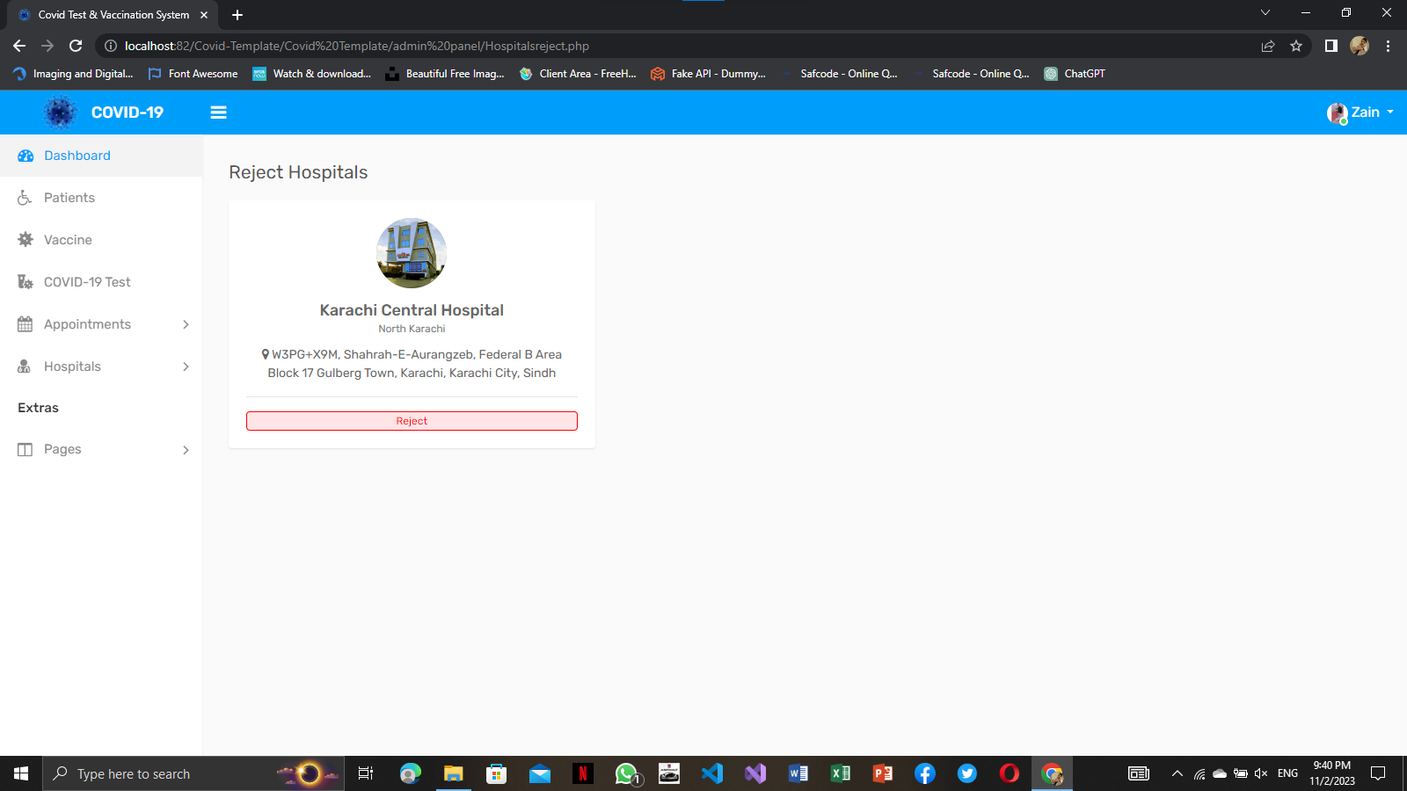

**CHANGE PASSWORD:**

Here is changing password option too.

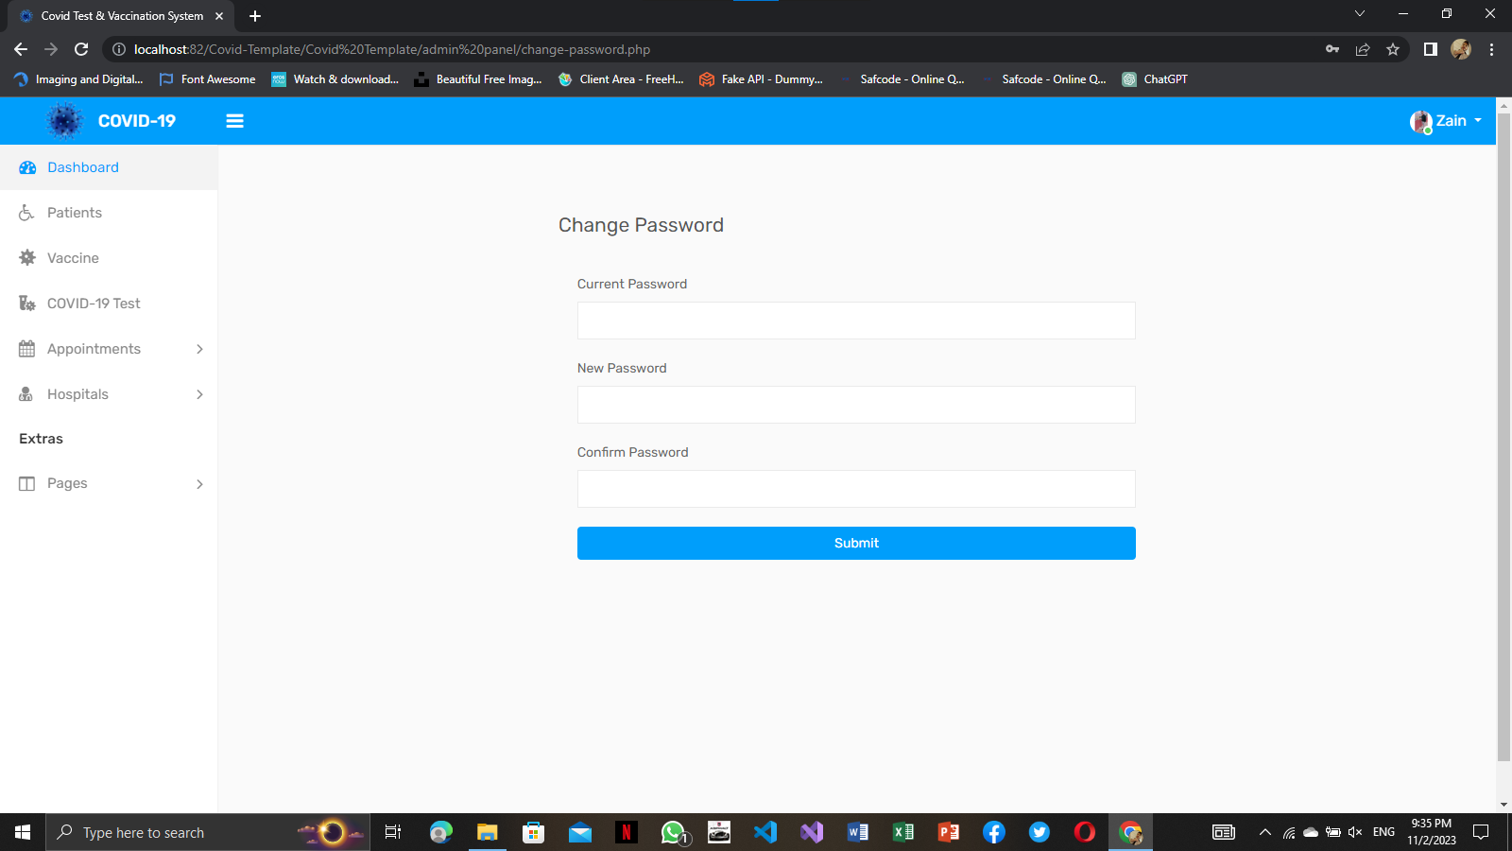

**PROFILE:**

Here you can update details you’re profile data.

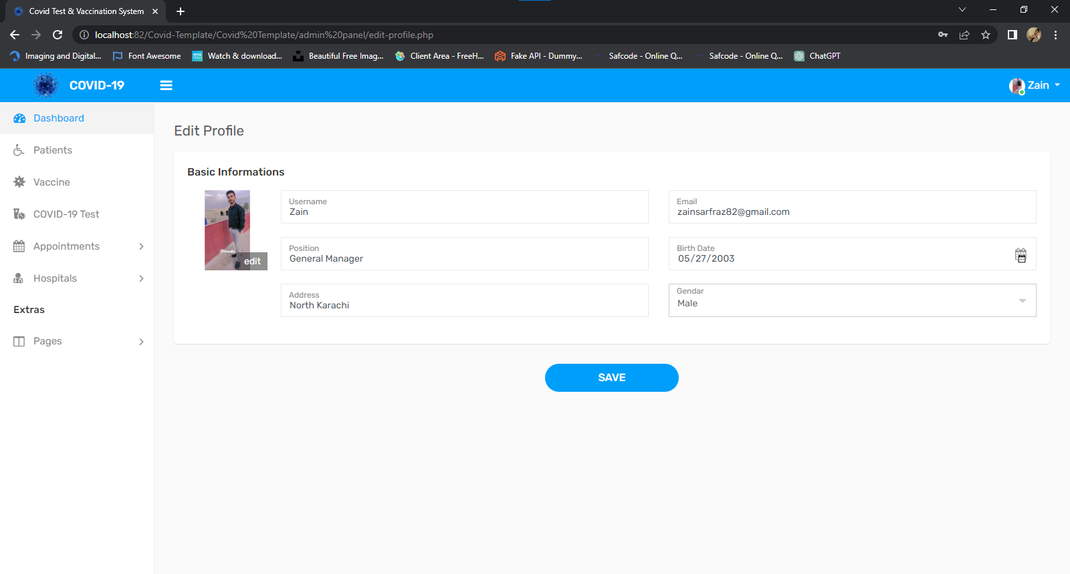

**ADMINHEADER/SIDEBAR:**

Here you can saw you’re all details related admin panel.



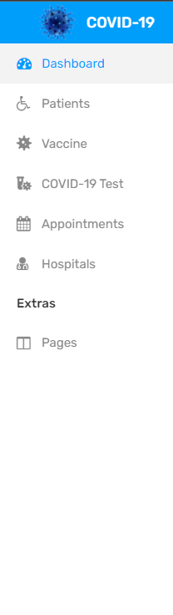

**HOSPITAL PANEL:**

**HOSPITAL REGISTER PANEL:**

Here is a Register page of hospital. Hospital can easily Register your account

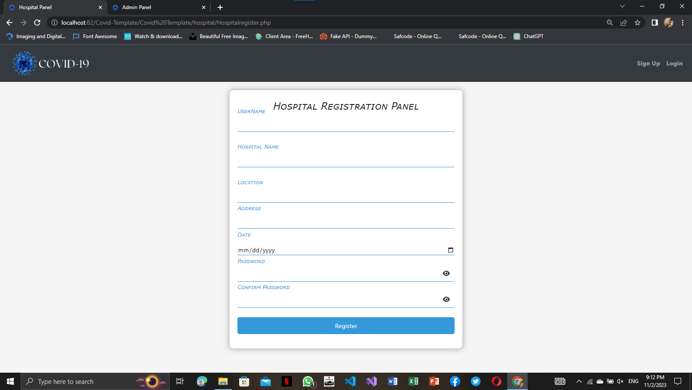

**HOSPITAL LOGIN PANEL:**

Here is a Login page of hospital. Hospital can easily

Login your account

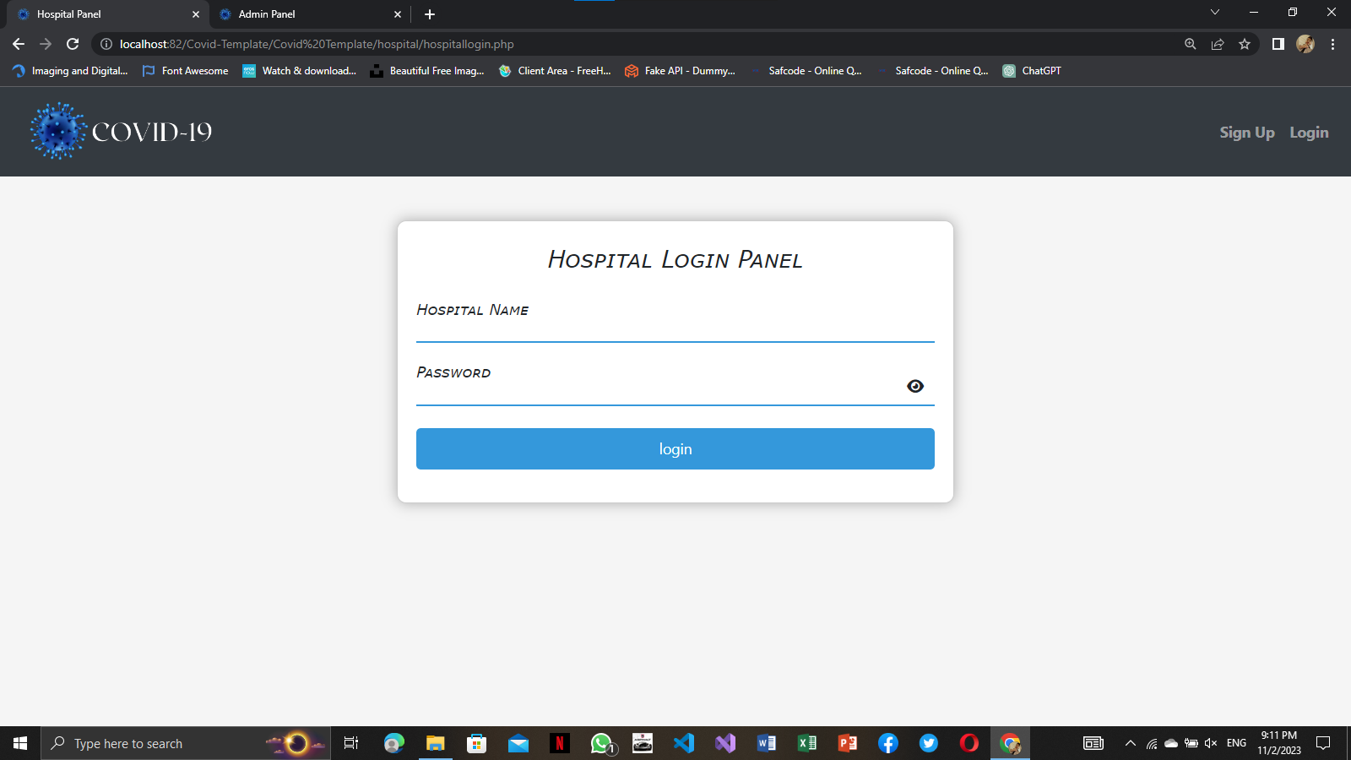

**HOSPITAL DASHBOARD:**

Here is a dashboard where can saw all hospital data

easily.

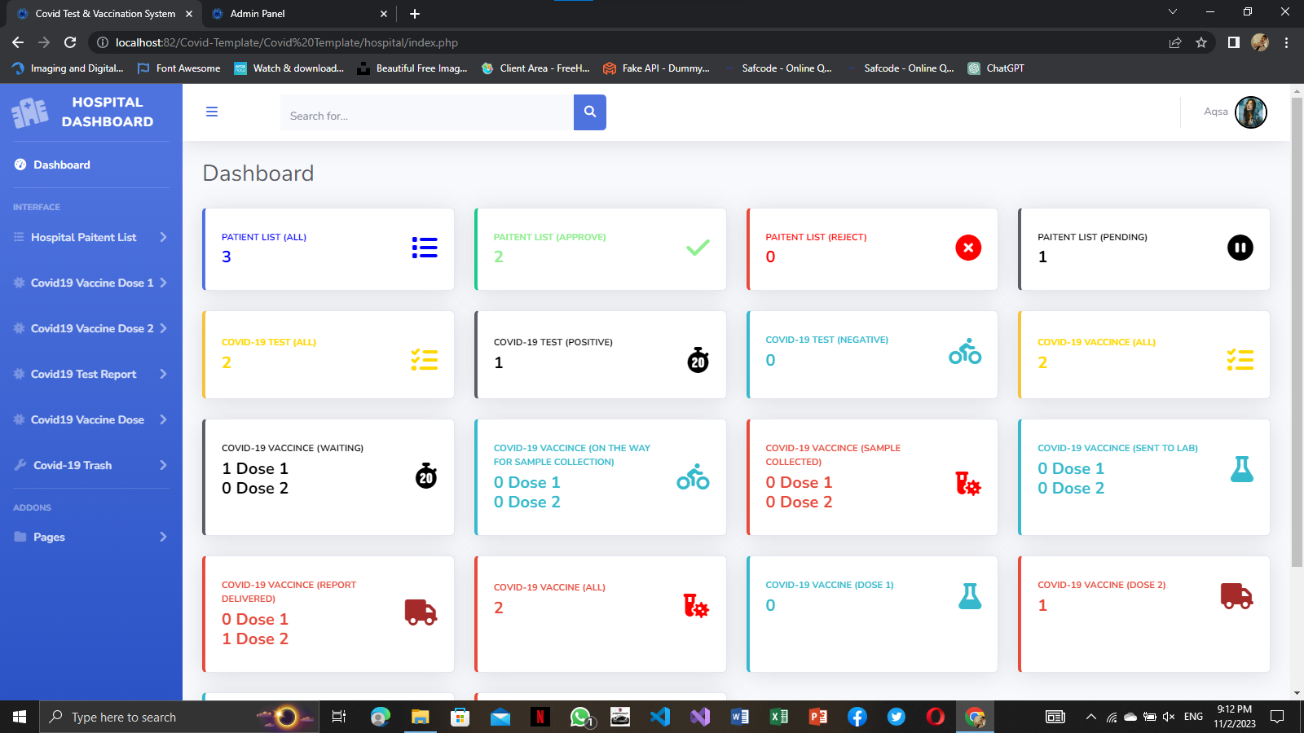

**PATIENT LIST:**

Corona virus Patient list see in this picture.

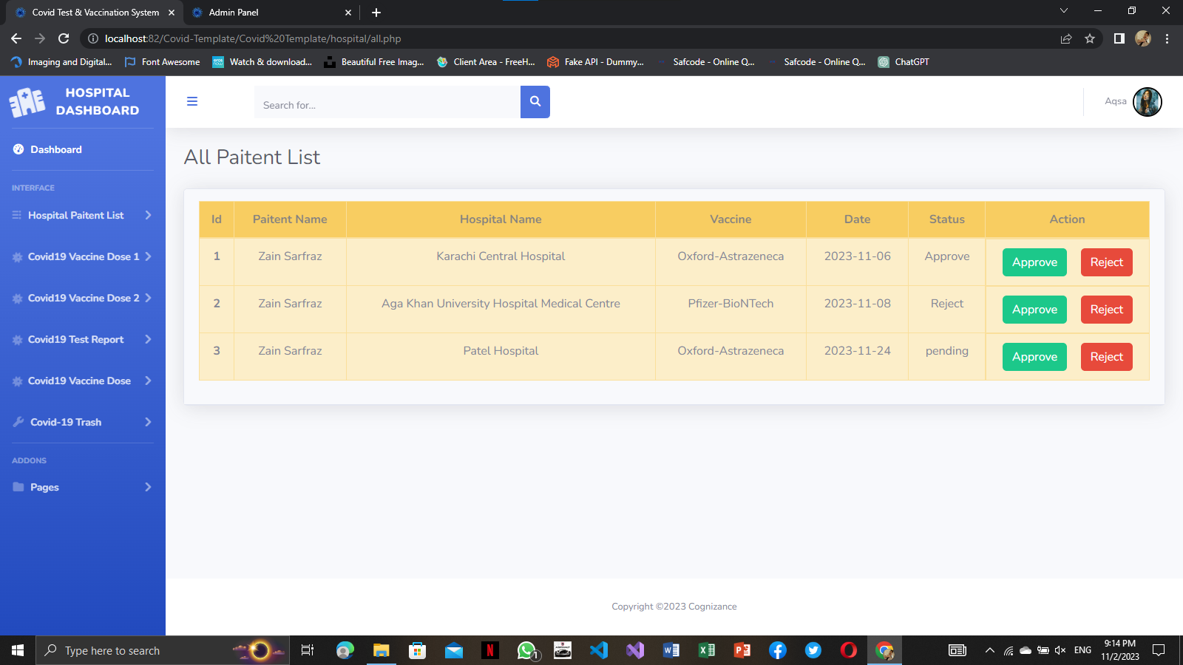

**DOSE 1 WAITING:**

Patient Waiting report list are here.

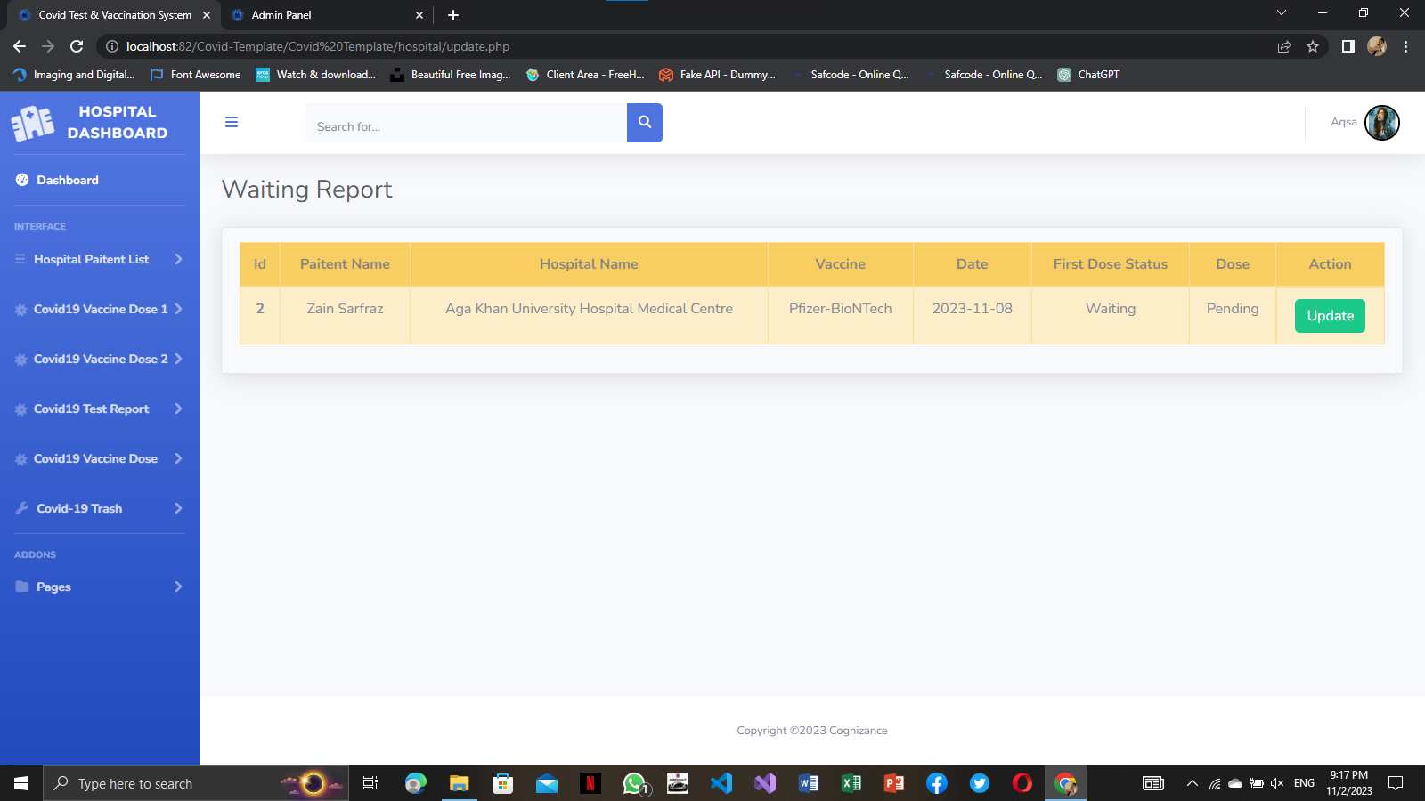

**DOSE 1 ON THE WAY:**

On the way are here.

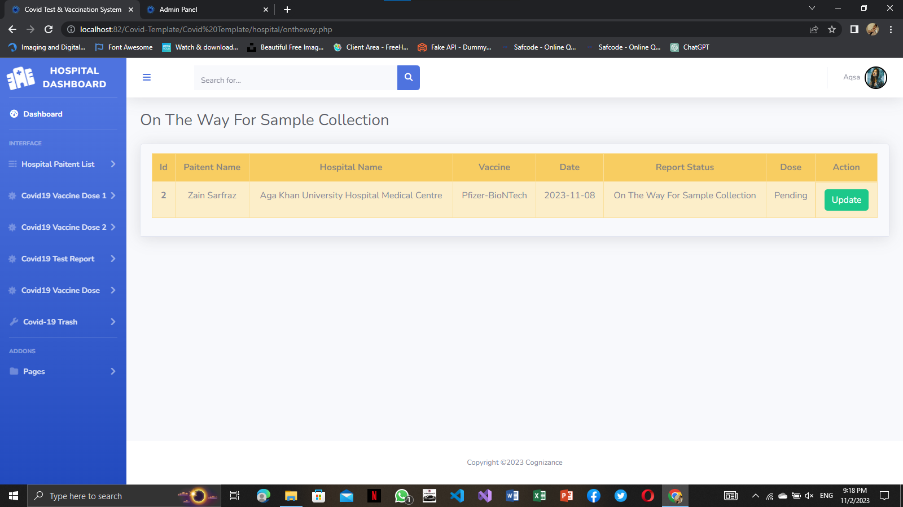

**DOSE 1 SAMPLE COLLECTED:**

Sample Collected Are here.

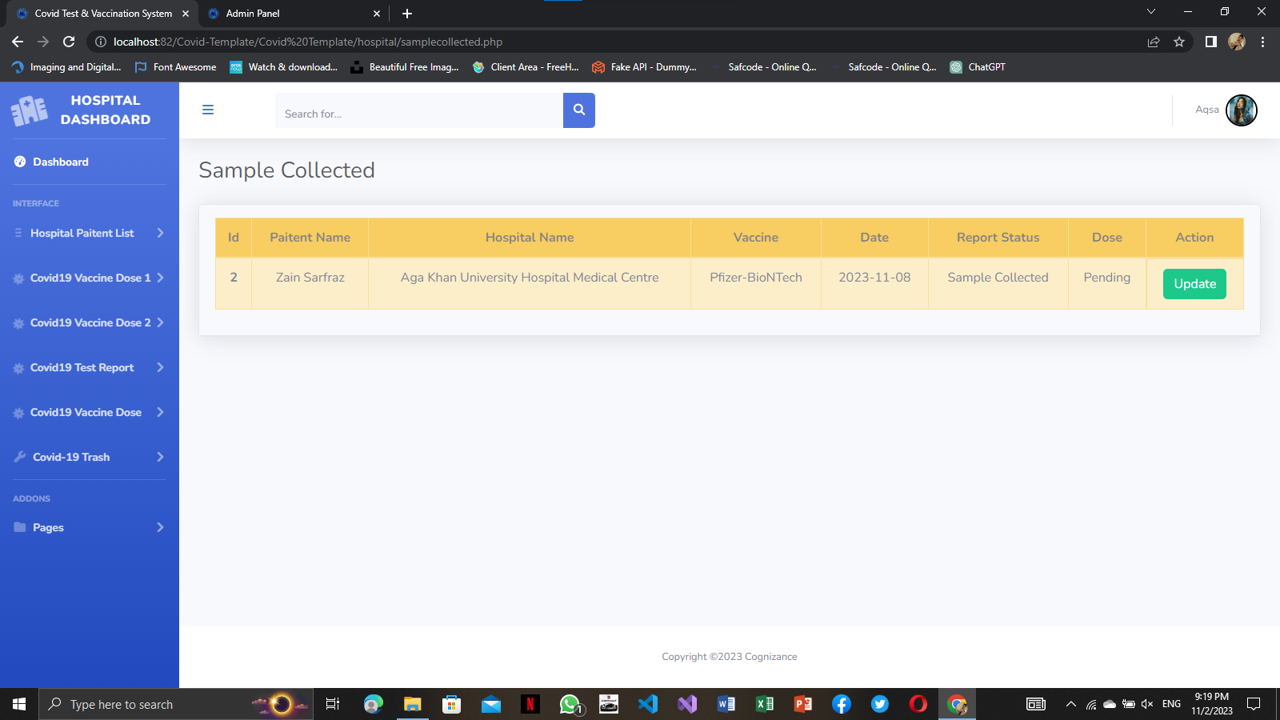

**DOSE 1 SENT TO LAB:**

Sent to lab are here.

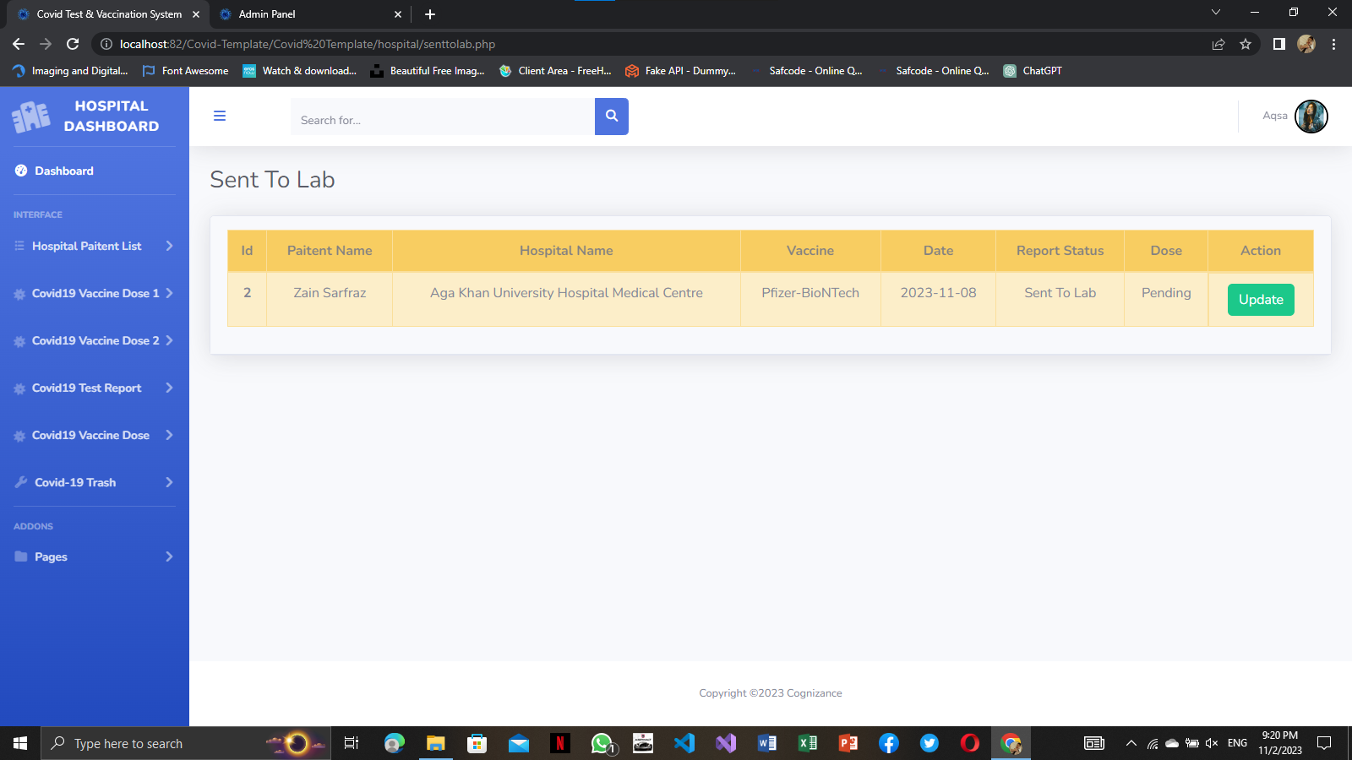

**DOSE 1 REPORT DELIVERD:**

Report Delivered Are here.

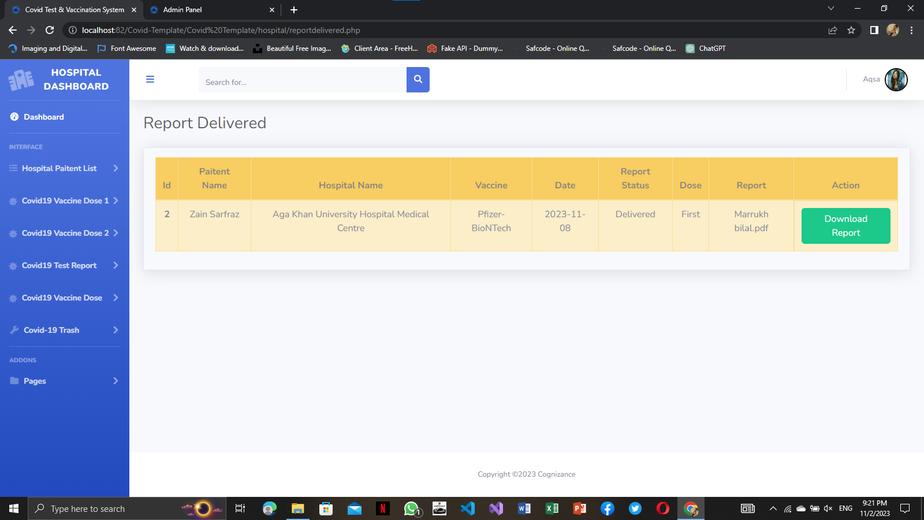

**DOSE 2 WAITING:**

Patient Dose 2 Waiting List are here.

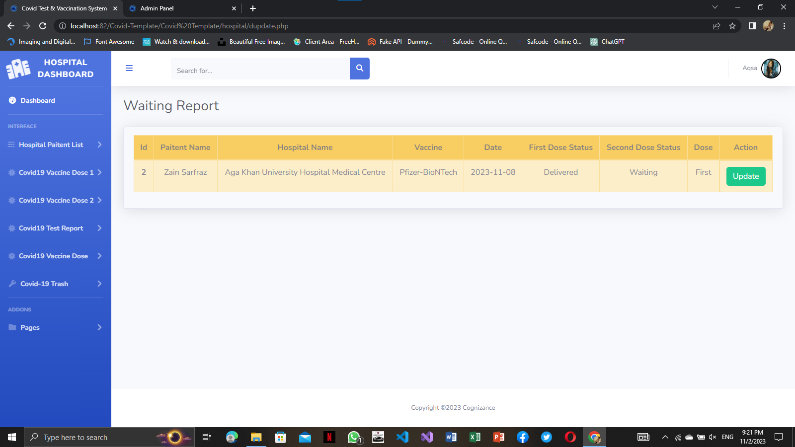

**DOSE 2 ON THE WAY:**

On the way are here.

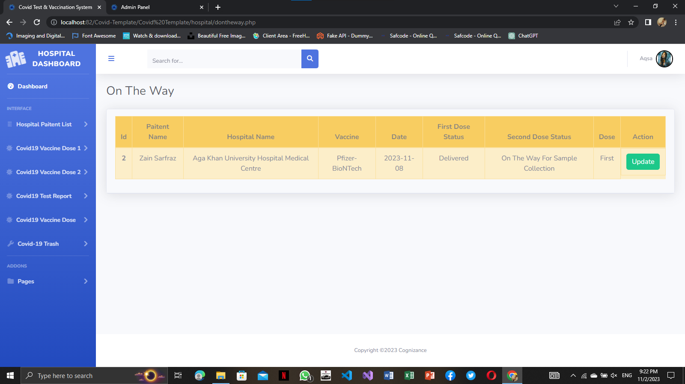

**DOSE 2 SAMPLE COLLECTED:**

Sample Collected Are here.

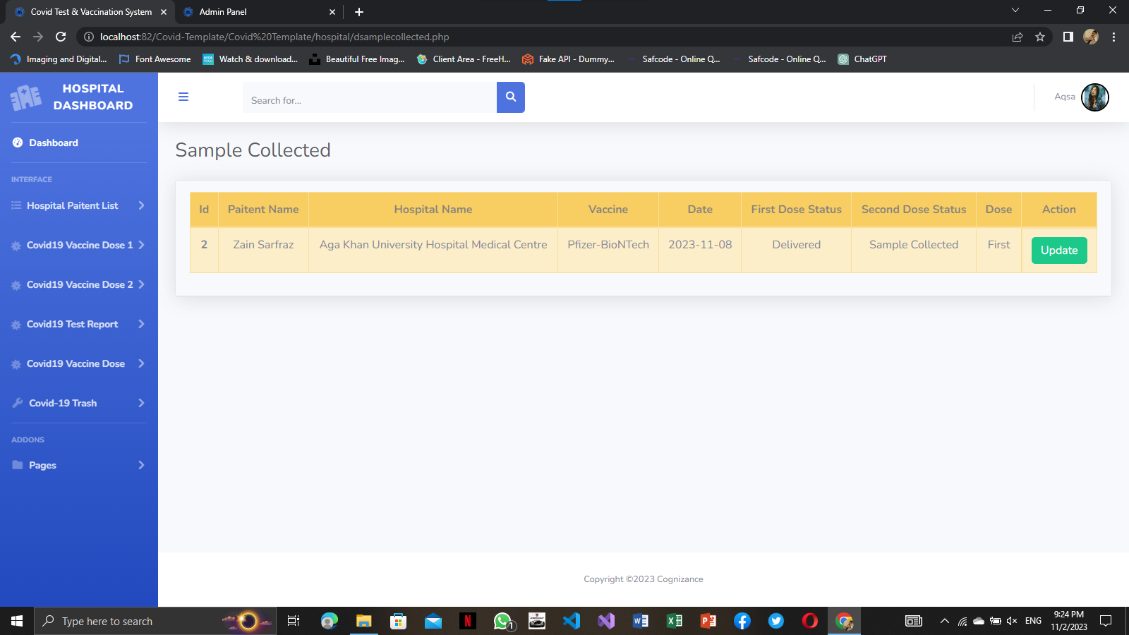

**DOSE 2 SENT TO LAB:**

Sent to lab are here.

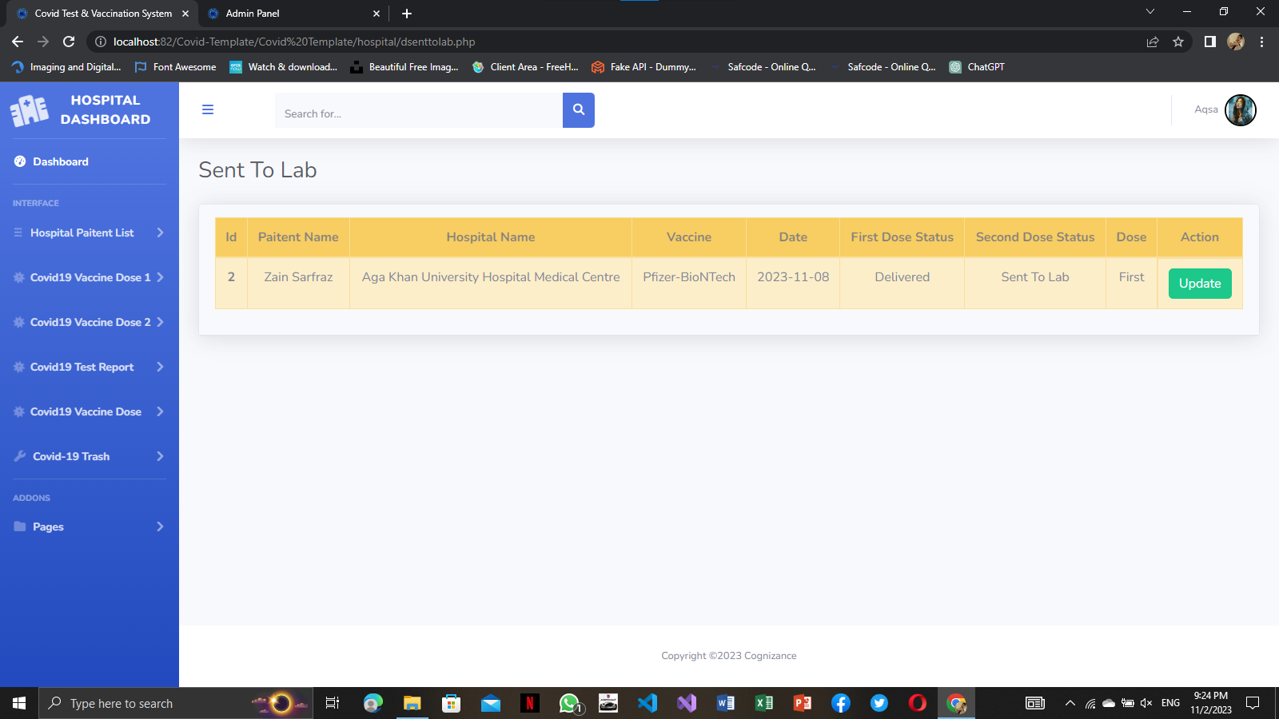

**DOSE 2 REPORT DELIVERED:**

Report Deliverd are here.

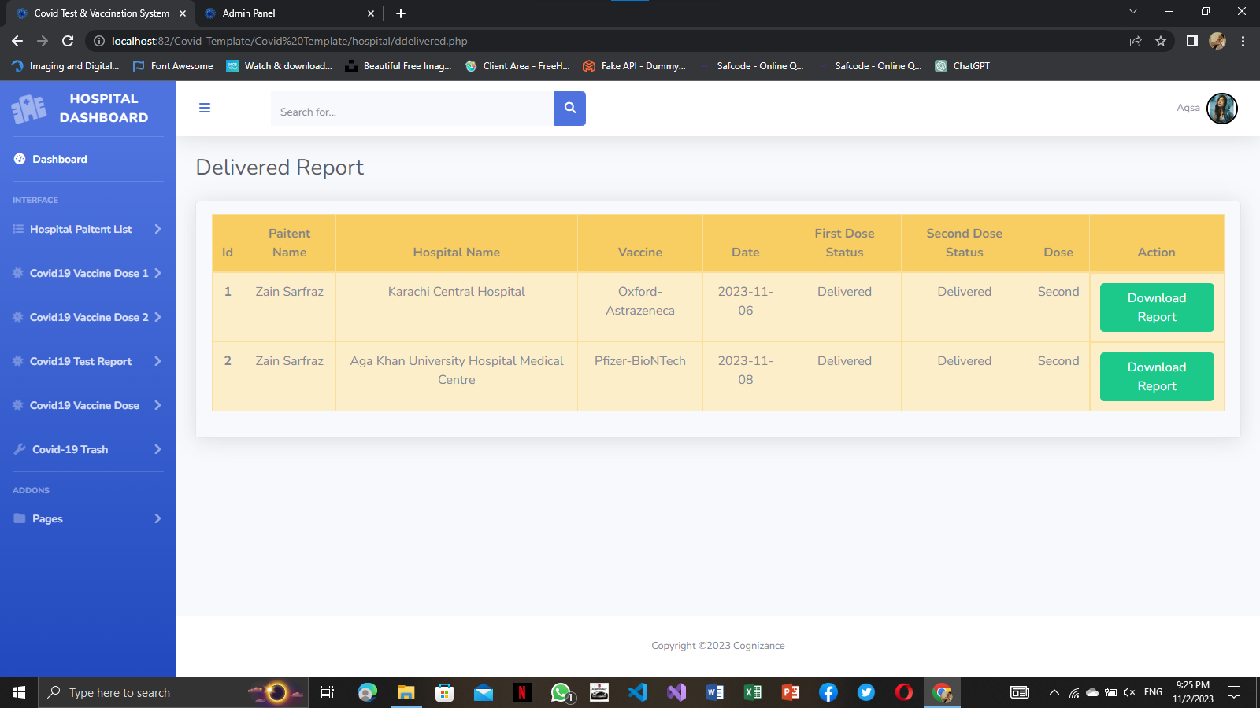

**COVID-19 TEST Report:**

\

All test of covid-19 patient list are here.

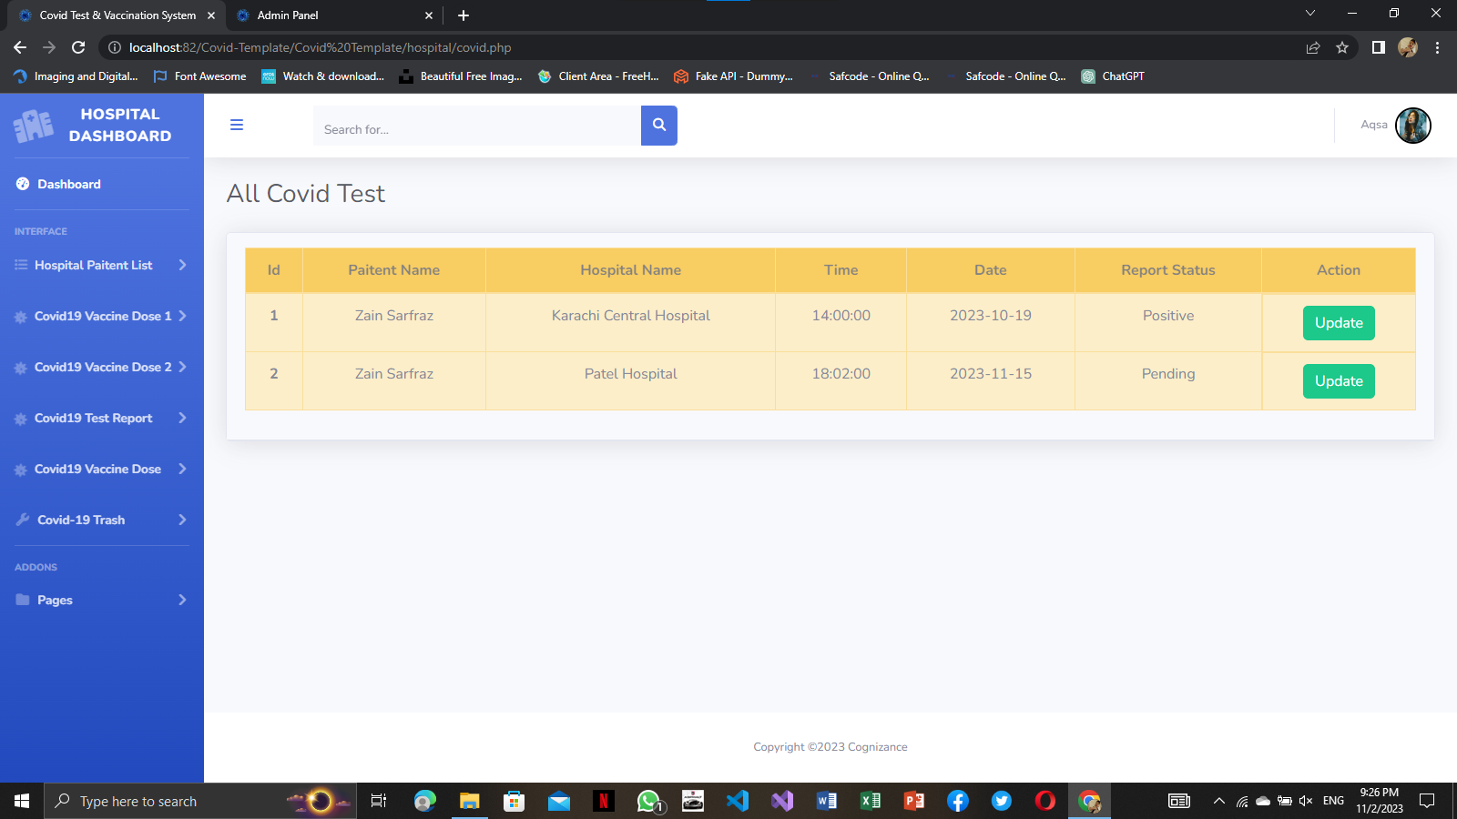

**HOSPITAL TRASH:**

Here is Hospital Trash data.

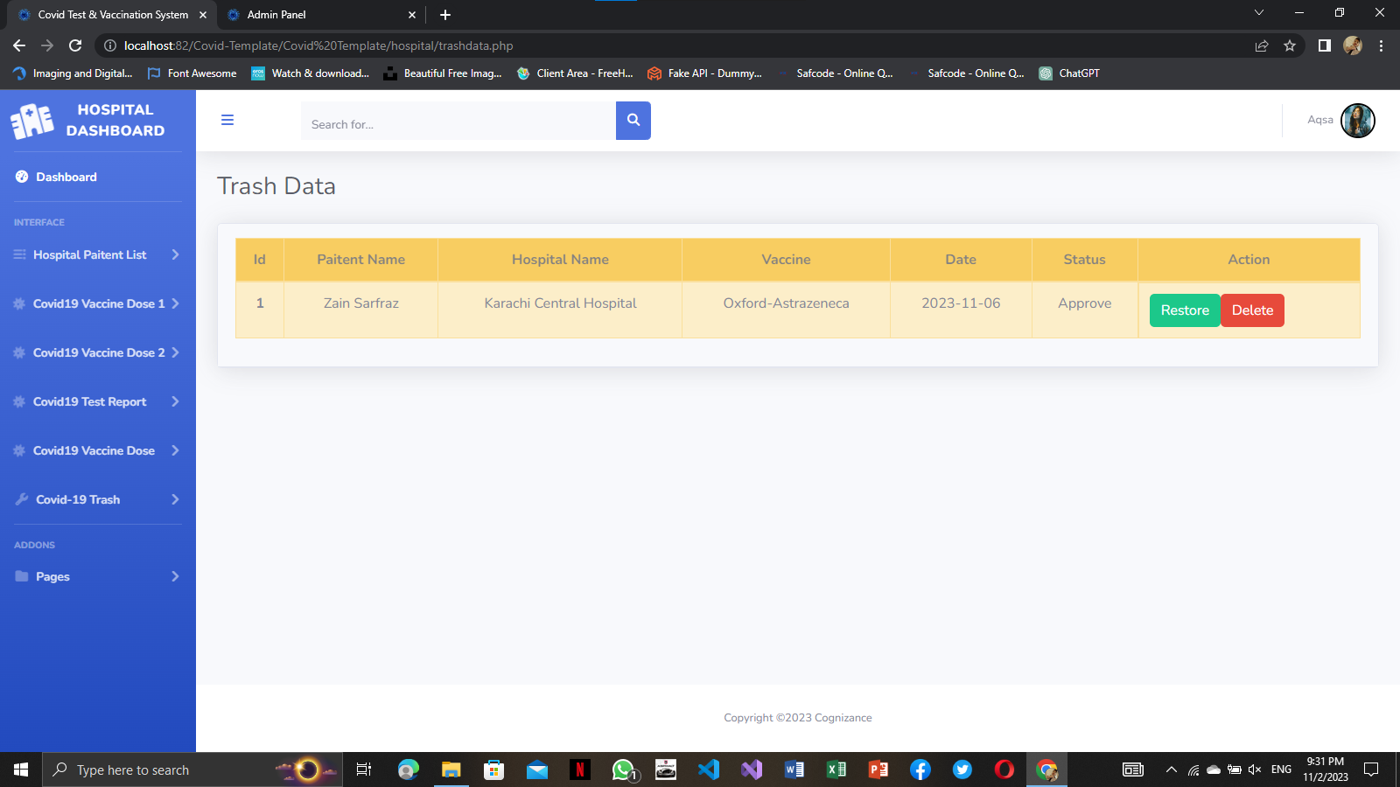

**CHANGE PASSWORD:**

This Website picture show change Password .

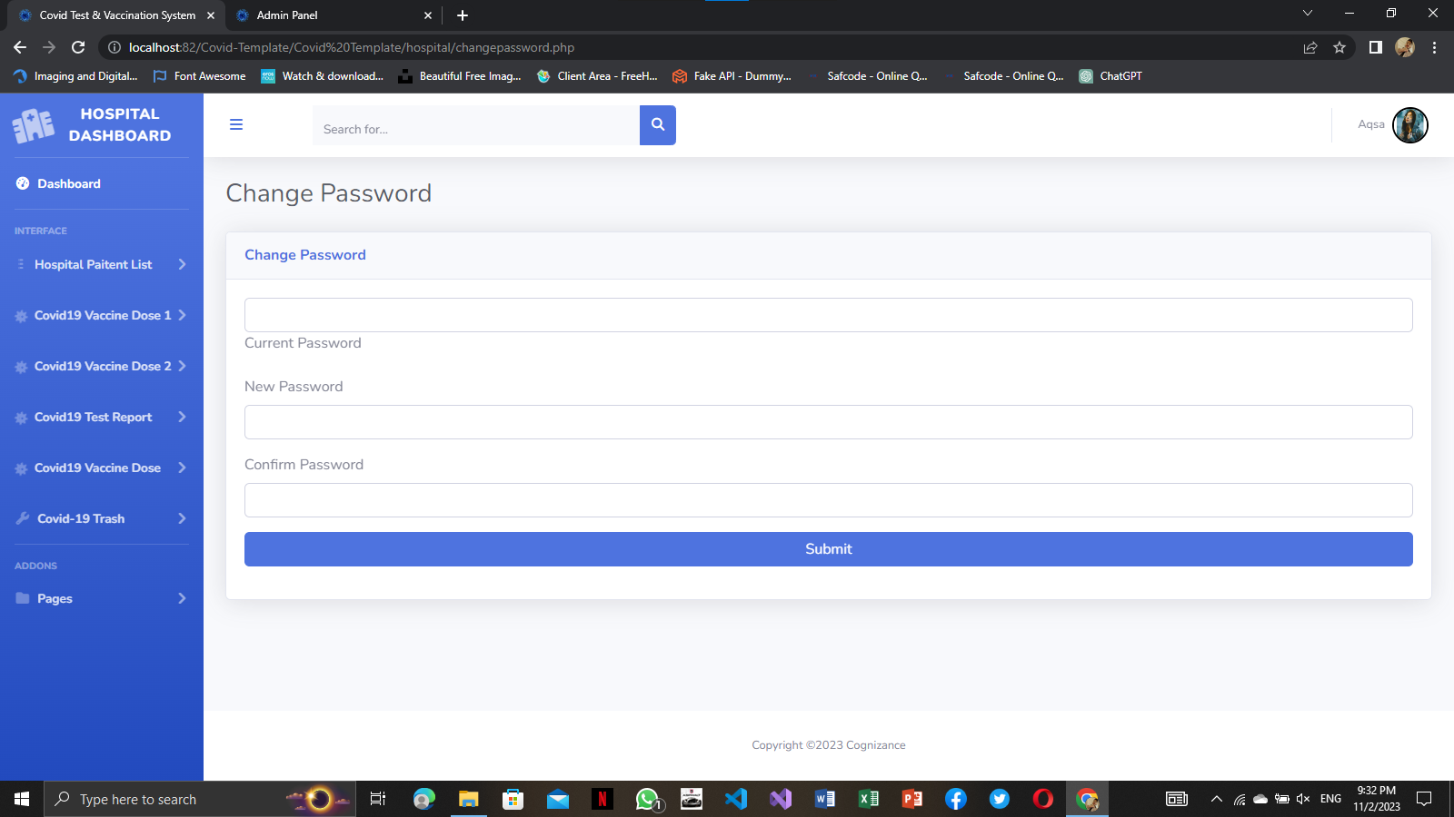

**HOSPITAL PROFILE:**

This Picture Show Hospital Profile.

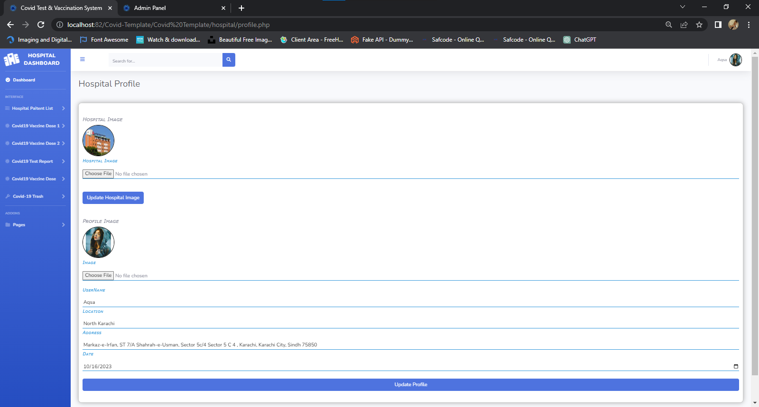

**PATIENT:**

**PATIENT LOGIN:**

Here is a Login page of patient , Patient can easily login

there Account.

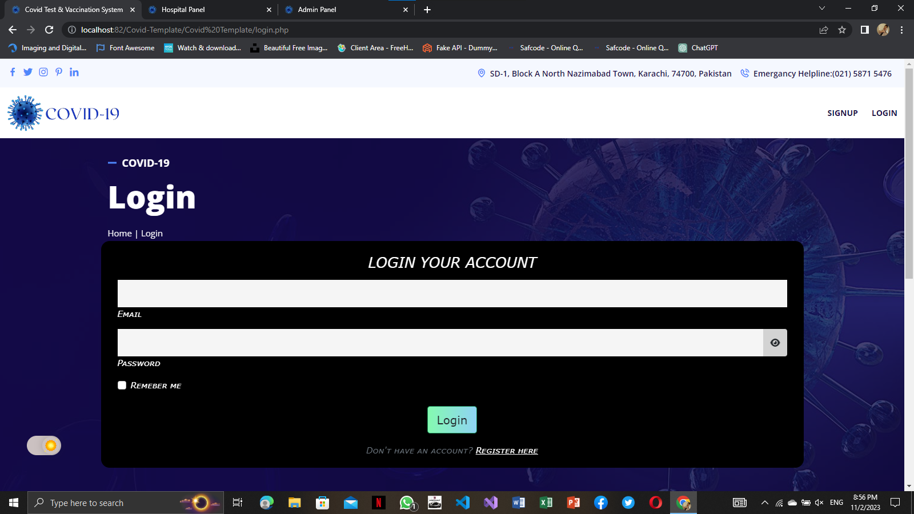

**PATIENT REGISTER:**

Here is a Register page of patient , Patient can easily

Register there Account.

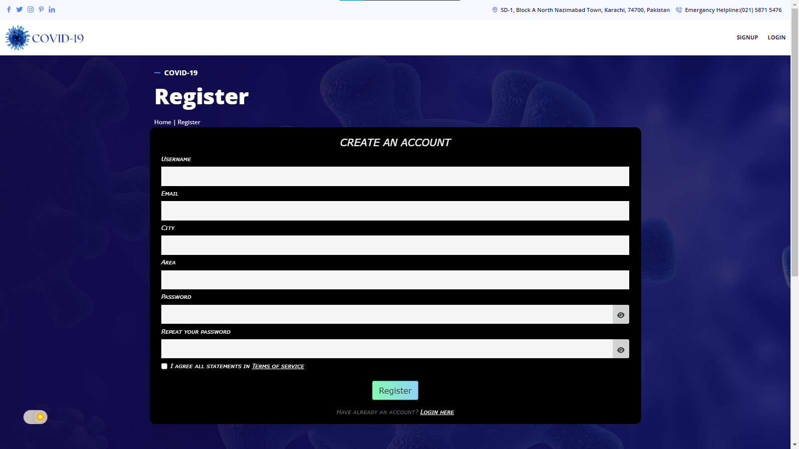

**HOME:**

Here a Home Page.

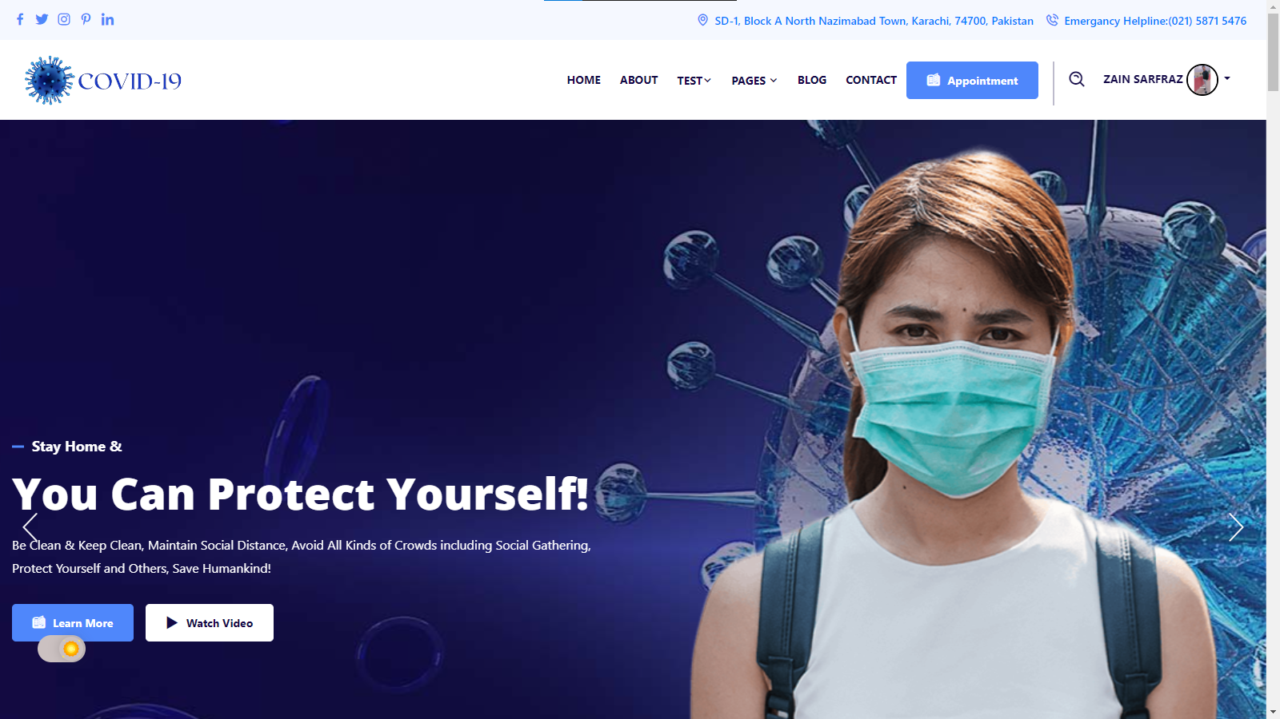

**ABOUT US:**

About information are as following:

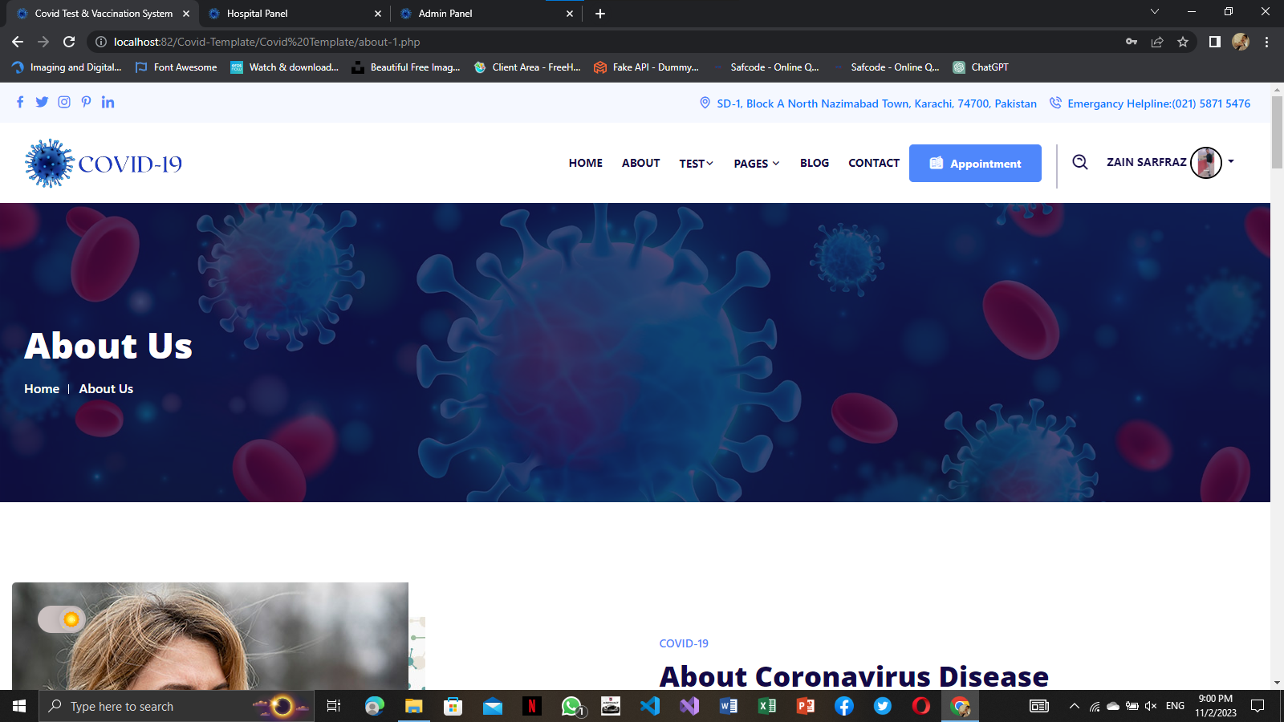

**HEADER:**

Here is header.



**FOOTER:**

Here is Footer.

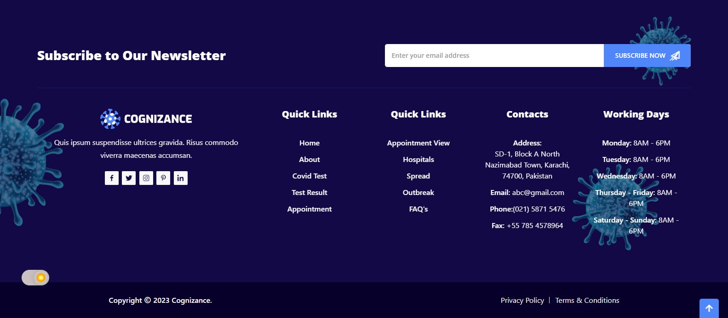

**COVID TEST:**

Here You book you’re Covid-19 test by easily

Over there.

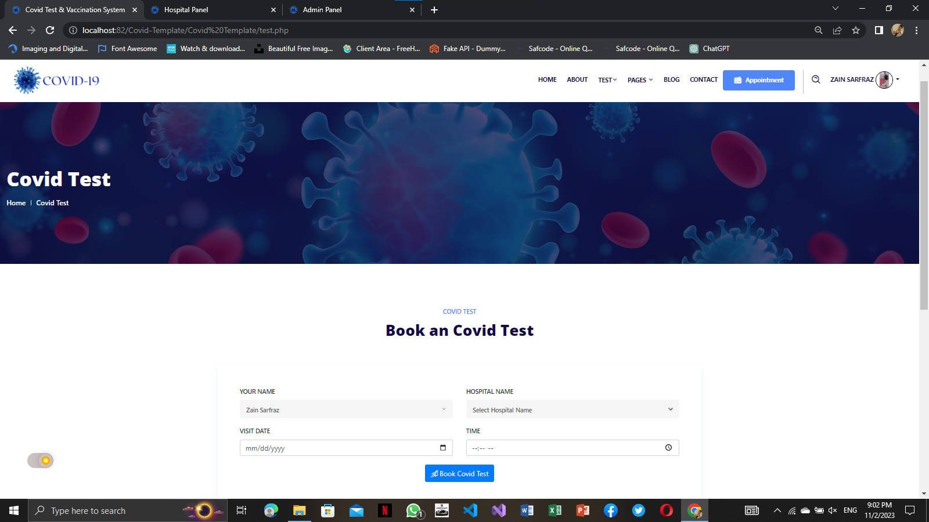

**COVID TEST VIEW:**

This is a place where you would saw a result related

You’re Covid-19 test.

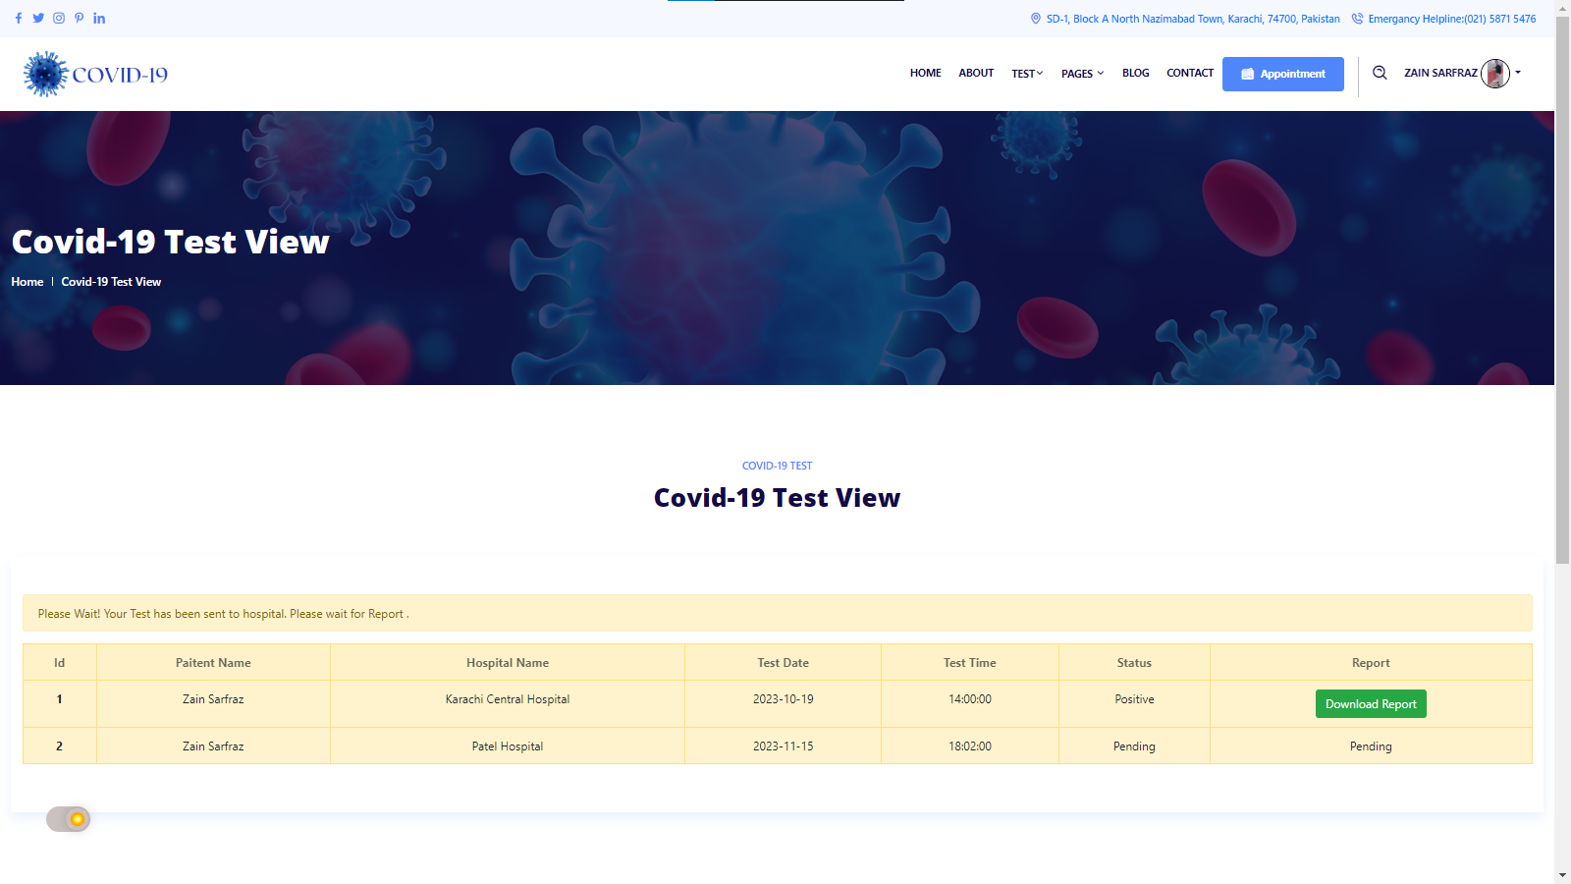

**APPOINTMENT VIEW:**

Appointment view part is over here.

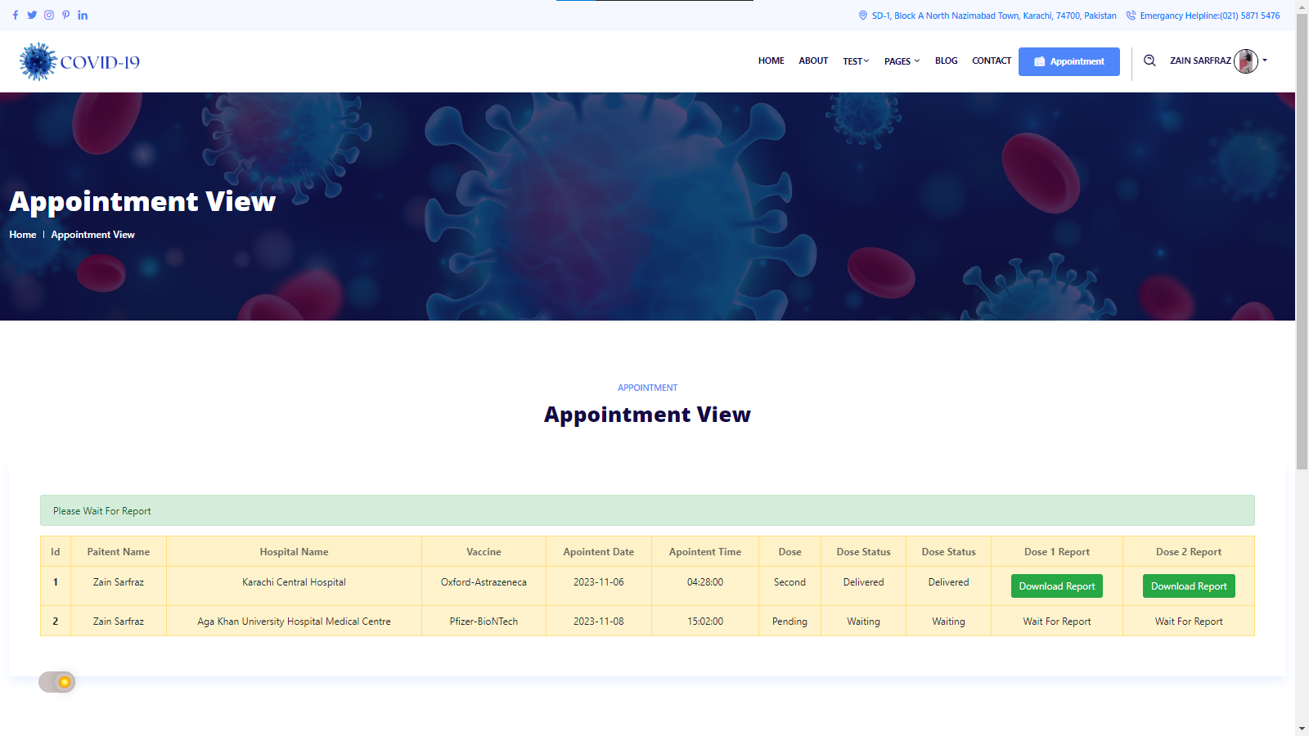

**RESULT VIEW:**

Covid-19 Result are here.

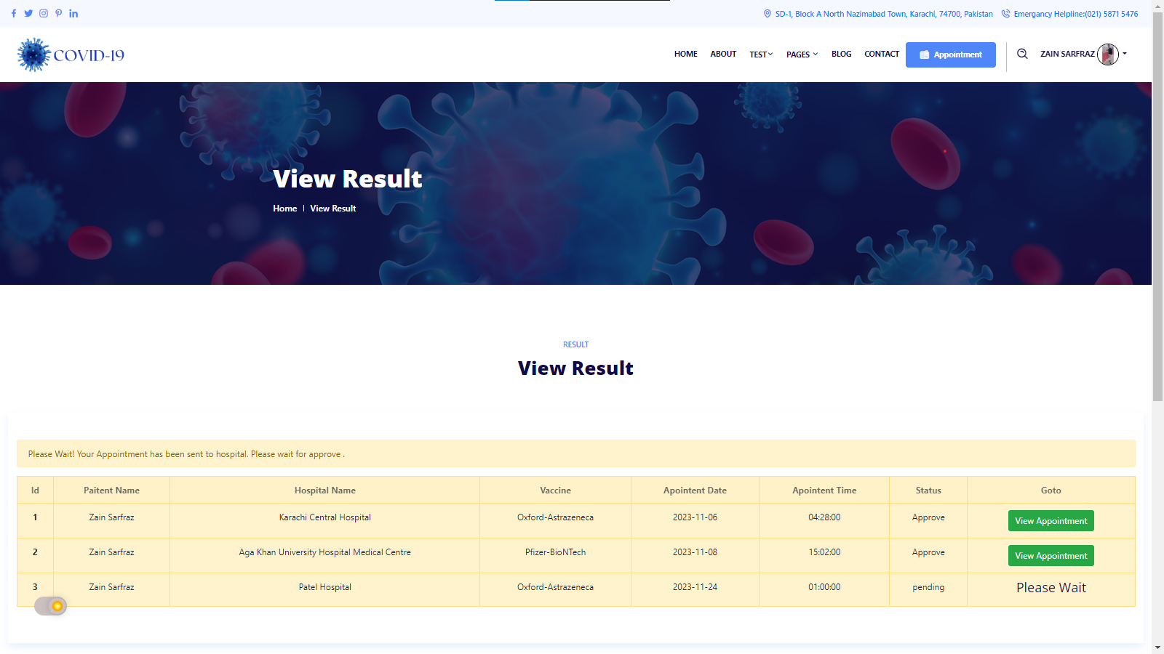

**APPOINTMENT:**

You can booking your appointment on there is easy

To use and patient easily identify it.

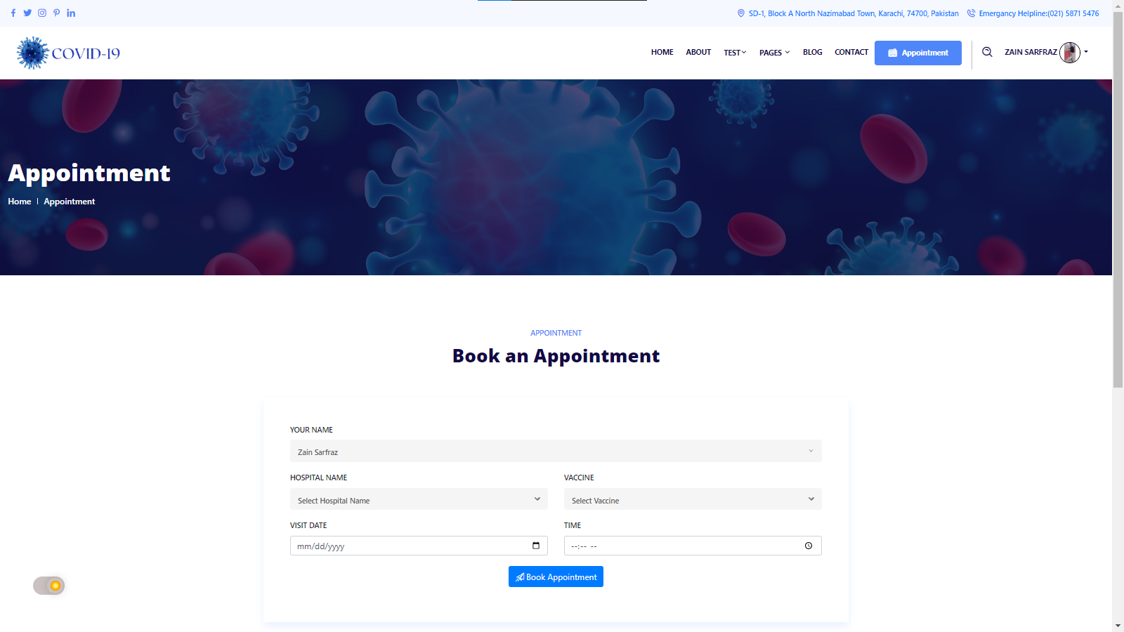

**HOSPITAL:**

Here is a Hospital Page Where we can saw all Hospital.

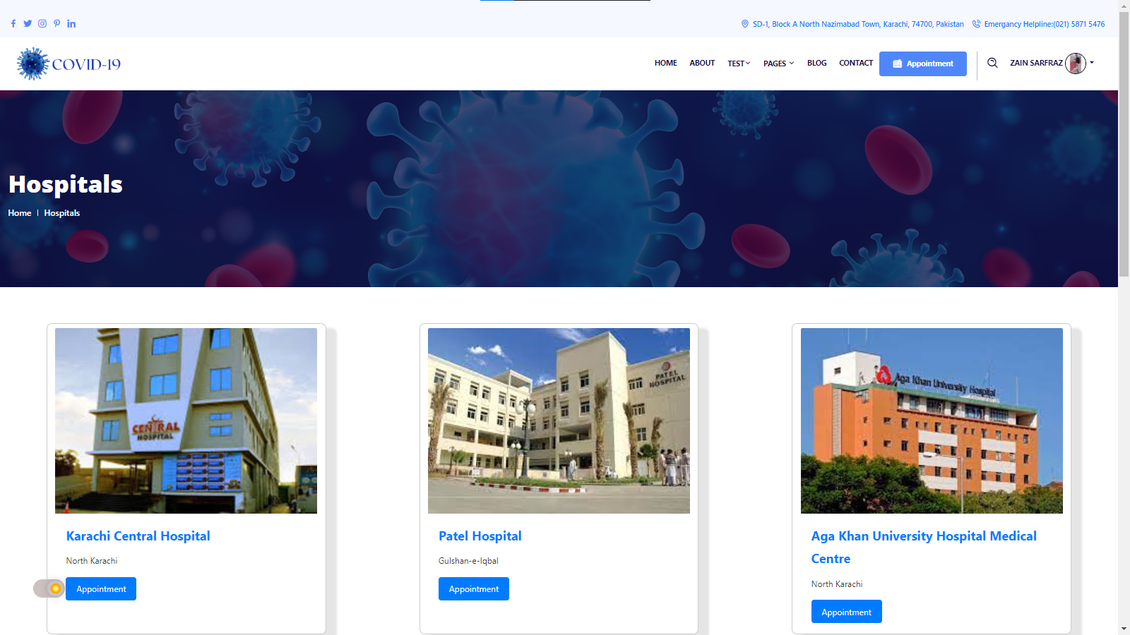

**SPREADS:**

Covid-19 Spread are here.

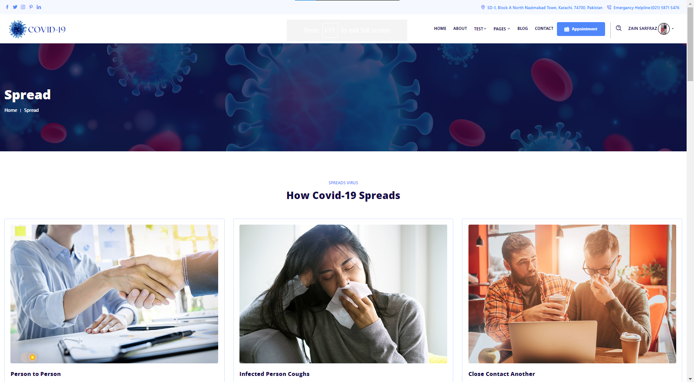

**OUTBREAK:**

This Website Picture show corona virus Outbreaks.

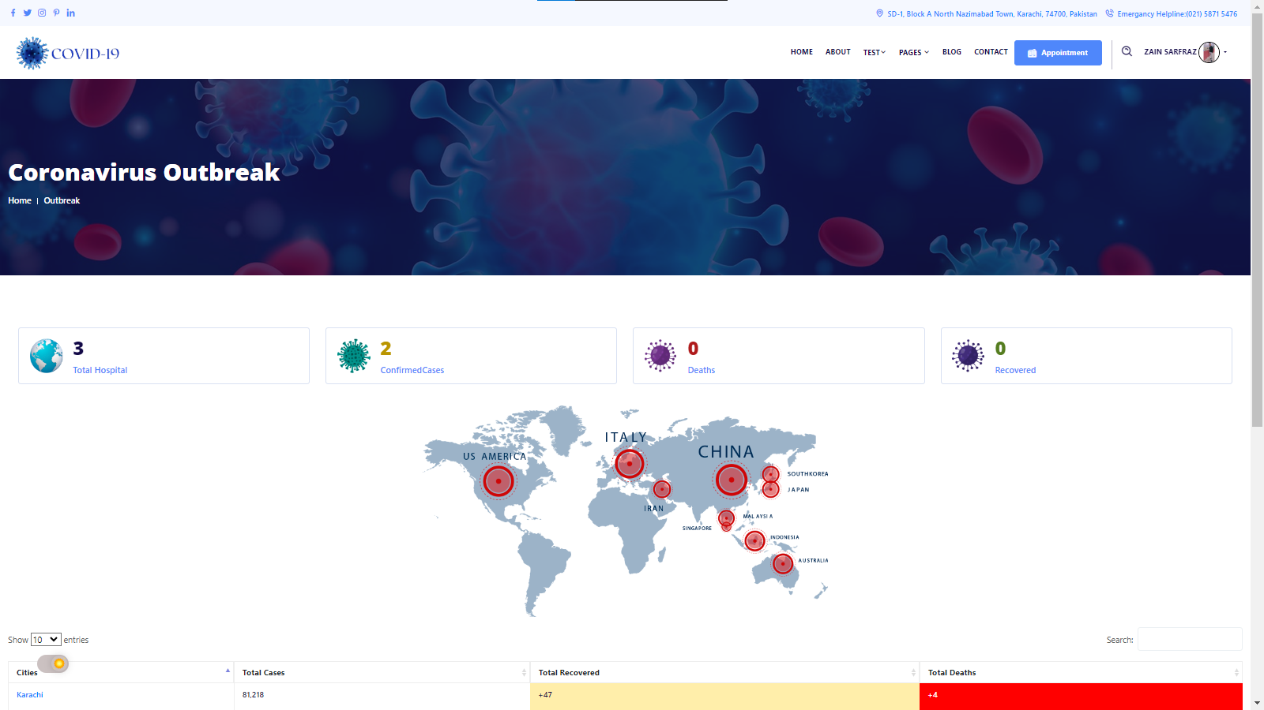

**FAQ:**

Here is Faq option too.

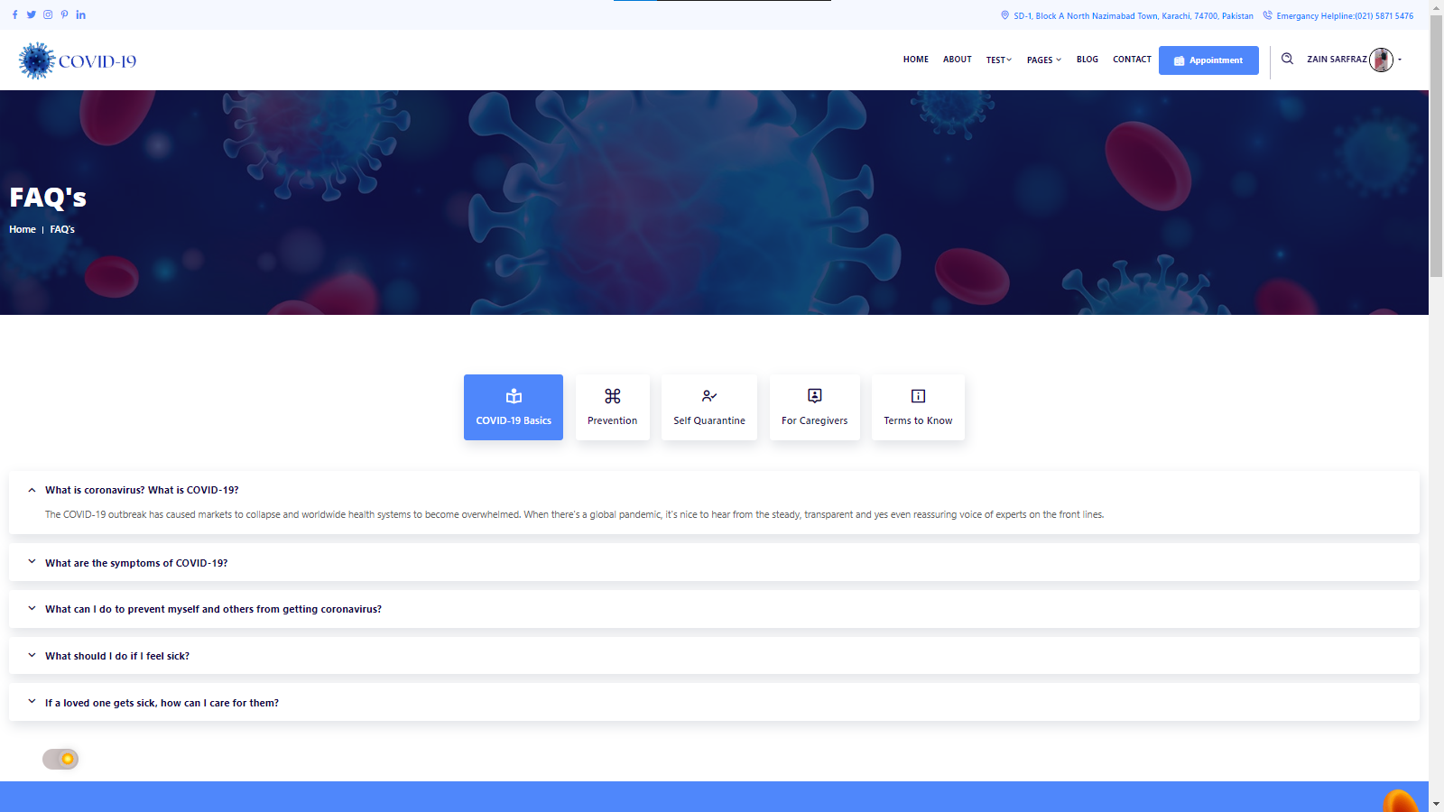

**BLOG:**

Blog part over here you get the information related this Website and our content.

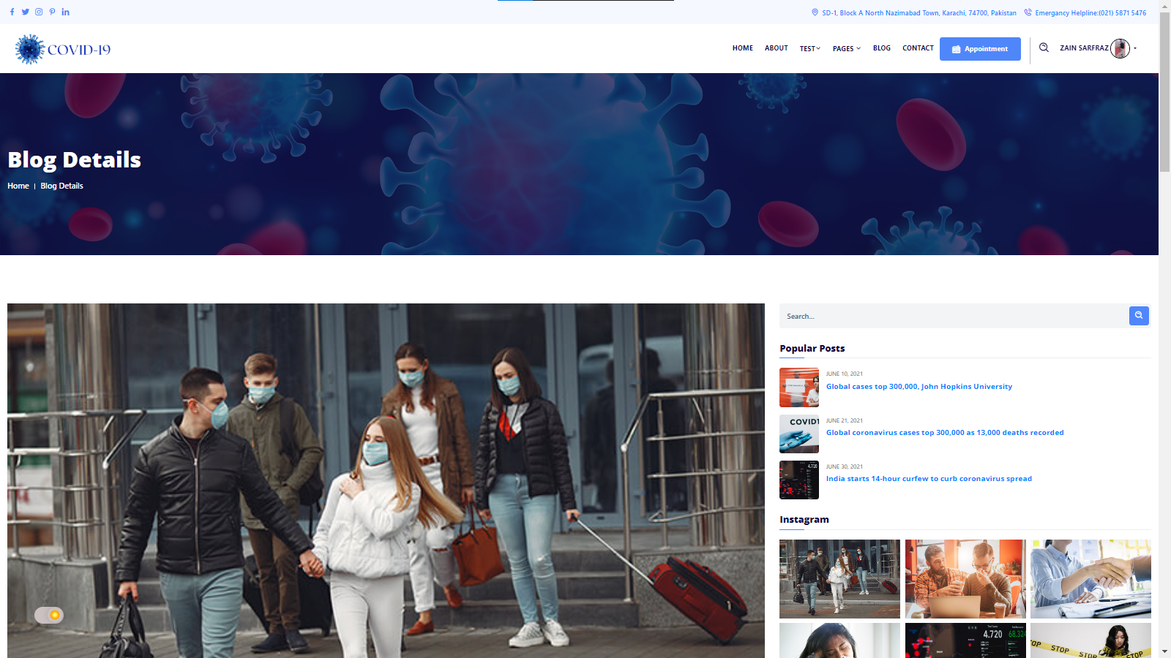

**CONTACT US:**

Here you can contact it and tell us about you’re details

and send us suggestion too.

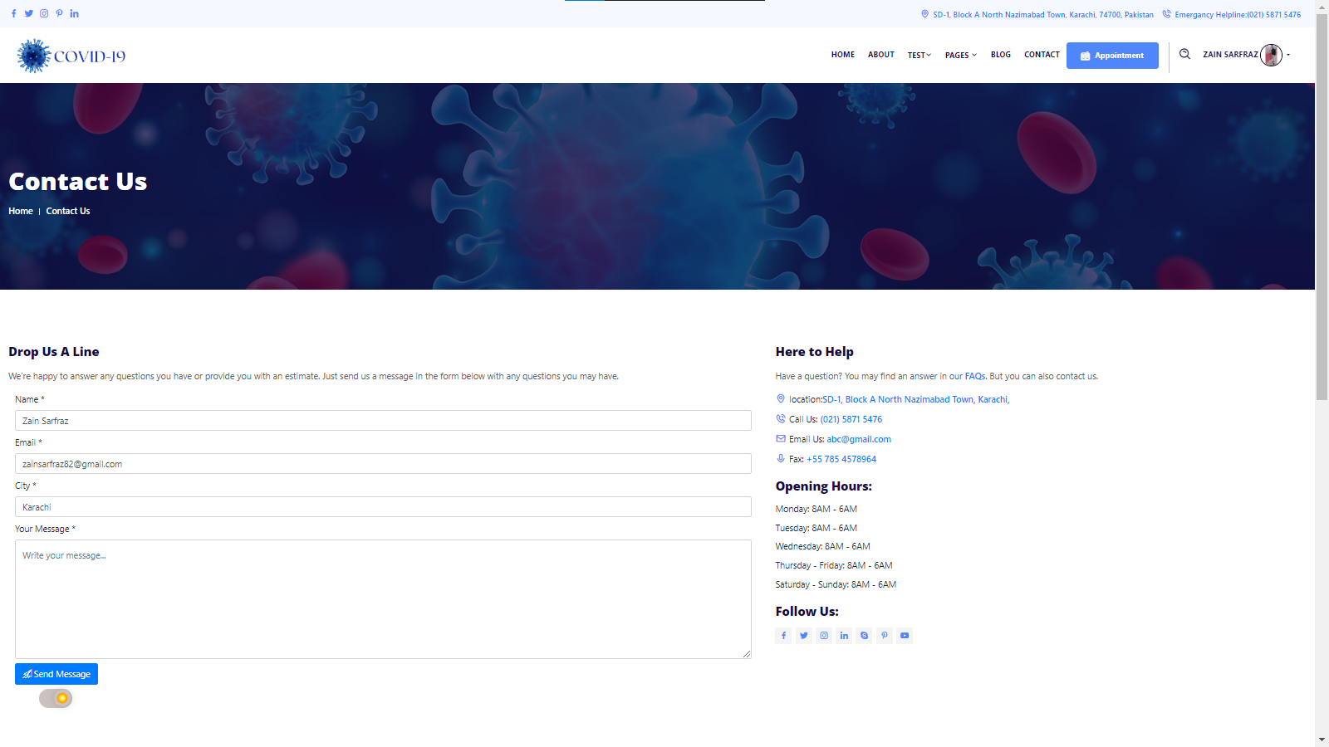

**PROFILE:**

User Profile data are as follow in this picture.

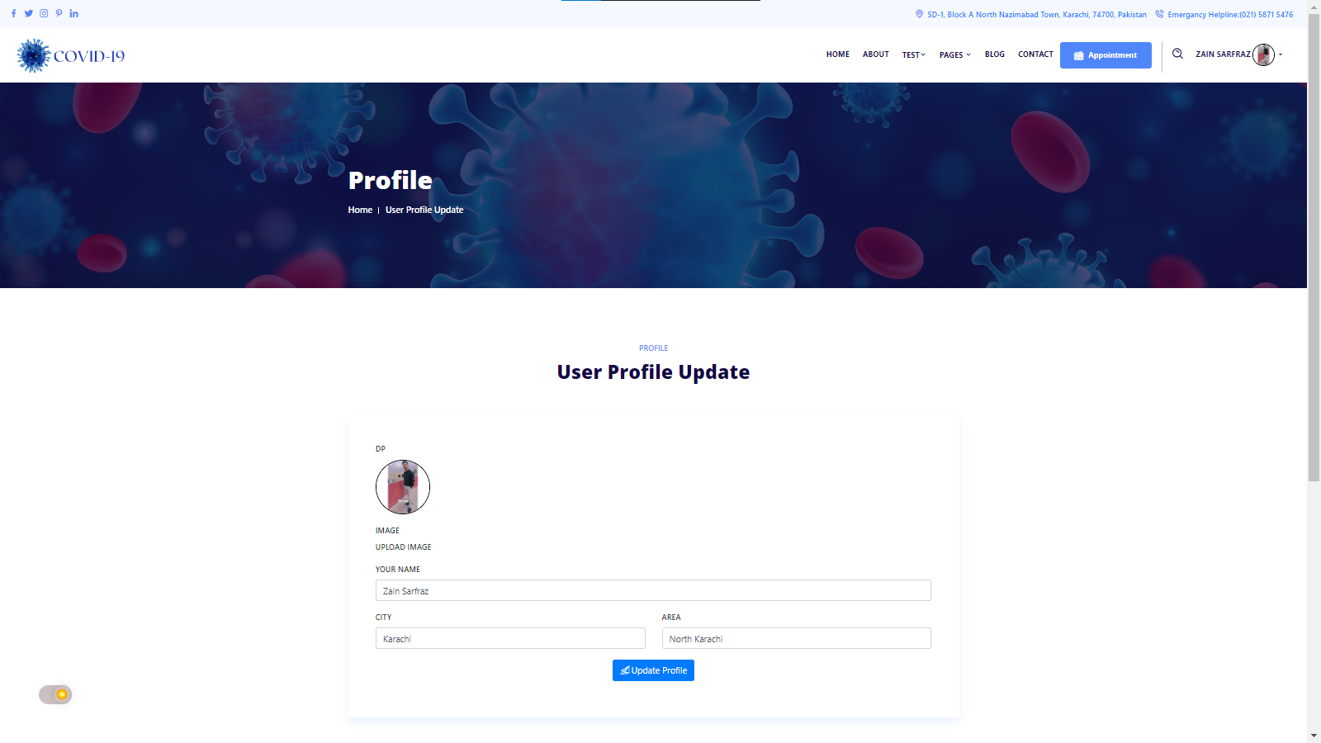

**CHANGE PASSWORD:**

Here is changing password option too.



